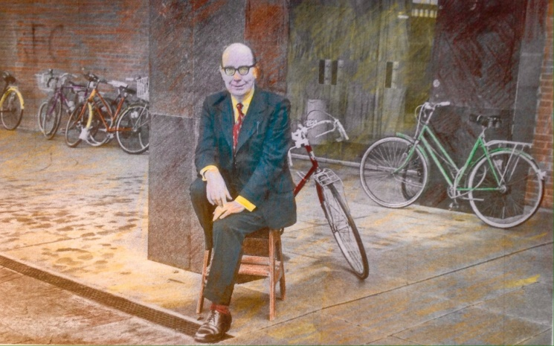
Philip Larkin says,”Bucks you up, your Bicycle!”
Update
With twenty-two identified ride leaders (6 active) and a great response from members with all rides being well prescribed, plenty of riders (29+) are taking advantage of the new arrangements. This represents a very successful re-start (More ride leaders stepping forward would help further). Thus, July saw the club, if not resurgent then demonstrating its current robust health.
The Government promoted its (revised-2017 plan- £5 billion of new investment) Cycling and Walking Investment Strategy, underlining the groundswell movement emerging during the lockdown.
It outlines further measures to transform cycling and walking to deliver the government’s aims to double cycling and increase walking by 2025 – including: 1. The creation of a national cycling and walking commissioner and inspectorate; 2. Higher standards for permanent infrastructure across England; 3. Getting GPs to prescribe cycling and exercise; 4. Creating a long-term budget for cycling and walking similar to what happens for roads
There have also been reports and articles stressing the link between cycling, health and well-being. With club members out and about, we don’t need convincing, but it is definitely a good time to be a cyclist and a Cycle Somerset member.

World Bicycle Day 2020 back in June promoted…
1. A sharper mind: Cycling exercises the body and strengthens the brain too, inducing better memory, creative thinking and reaction time. It helps with anxiety and depression.
2. A Peaceful Sleep: The more pedals you push, the more peaceful sleep you will get.
3. Vitality and Vigour Boost: A key cycling benefit is increased vitality and improved stamina.
4. Encourages Healthy Diet: Adopt a healthy lifestyle, boosting the immune system (inc cake!).
5. Longevity: There are two things we need to live a long life - health and happiness - regular cycling helps you attain both of these.
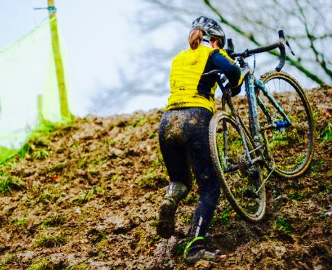
Climbing Hills 3: If you find yourself going up a hill like this, your ride leader needs to look at the navigational aid!
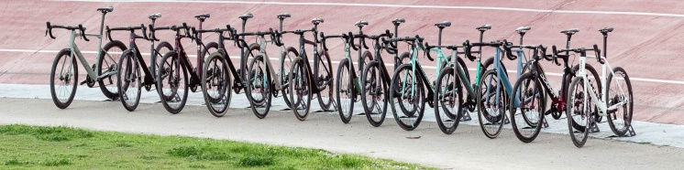
Does anybody have a D-Lock?
The Secret Cyclist...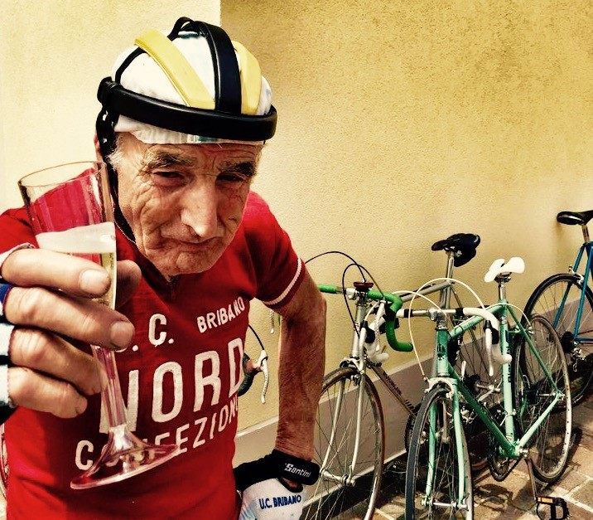 the ramblings of a mature perambulator!
The advent of the pandemic has provided as many opportunities to get on a bike as any person could wish for. I have rediscovered the freedom (and energy) of my childhood. I do not look at a mirror in the attic to confirm my youth, just the trusty steed I mount daily. My morning ride to the village to pick up my newspaper and the occasional home made scotch egg, takes me past abundant hedgerows with the cries of the buzzards spiralling overhead…it is the highlight of my day.
Even the Swallows have consented to confirm this idyll, soaring above and settling on wires in numbers not seen since an almost forgetten, halcyon, age.
Website and rides
In July, Richard Sykes was appointed our new IT lead setting up templates on our website for rides. Between now and October (last week’s meeting) we will continue to have short / medium / long rides on Tuesdays, Thursdays, and Saturdays (6 riders).
During July we had short rides to various destinations including Thurlbear and Creech, medium to Bishops Lydeard and Bridgwater and longer rides to Chard, Culmstock and Watchet.
The guidelines limiting rides to six people led to club members saying how much they are enjoying these smaller groups. Ride leaders have commented that a group of six feels like riding with friends and is not onerous, especially on a familiar route.
As stated we have twenty two leaders but more active leaders would help. The website has useful info about how to lead a ride safely. When you lead your 2nd ride you will wonder why you worried about organising the first! Further info e.g. ‘How to’ has practical tips like reading a map, mending punctures, checking a bike before a ride and using a Garmin.
‘Routes’ section has a good range of rides for you to explore. The ‘Gallery’ section needs updating for any photographers wanting a project. Jonathan
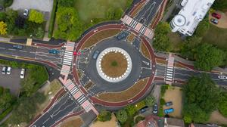
The UK’s first Dutch-style roundabout, prioritising cyclists and pedestrians over motorists, opened in Cambridge. Cyclists have an outer ring, with cycle crossings over each of the four approach roads. There are zebra crossings over each approach road for pedestrians. Motorists must give way when joining and leaving the roundabout. Reduced lane widths on the roundabout and at exit and entry points are designed to encourage drivers to slow down. Roxanne De Beaux, executive director of the Cambridge Cycling Campaign, said the new roundabout “Feels like a small piece of Dutch cycling heaven”.
The Female Saddle
Do Female Riders need Women’s Bike Saddles?
It isn’t clear cut but when it comes to saddles, most women will find a female specific design more comfortable. Most women have wider sit bones than men – so the rear of the saddle usually needs to be wider. Cut outs and channels, designed for men, were soon preferred by women urging the industry to respond now most of women’s saddles have a gap or groove. Chatting to other riders is a good idea.
How do you choose the right saddle?
You have a better chance of getting your saddle right in the first instance if you take some time to look at your riding style and current discomfort before you shop.
How do you sit on the bike?
When sitting in a forward position – low and stretched out – soft tissue discomfort is more likely; these riders often get on well with saddles with a flat and short design and a large pressure relief area – the Selle Italia SLR Lady Flow is an example, the Specialized Power also suits this rider well, as do ISM saddles.
Sitting further back in an upright position, you’ll likely want a curved saddle with more padding at the rear - Sella Italia Lady Gel flow. As a rule, your saddle width should be wider than your sit bones.
Cycle Weekly’s pick of the best women’s saddles
Listed below are the best styles. Remember each model is available at assorted prices, so shop around. More expensive versions are usually lighter, often with carbon rails reducing vibration. Any views from club members or handy hints would be welcome.
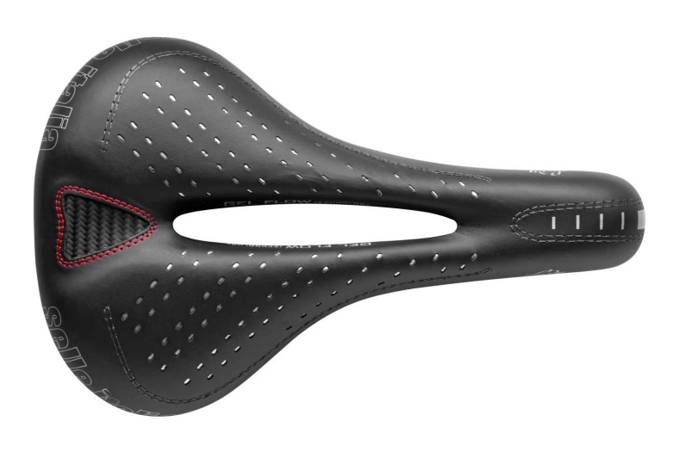
Highly recommended: Selle Italia Lady Gel Flow
In no particular order: Specialised Power (£184); Specialised Power Pro (£140); Specialised Romin Evo (£126); Fizik Luce Women (£54); Selle Italia Lady Gel Flow (£74); Selle Italia SLR Lady Flow Women (£83);ISM PN 1.1 Saddle (£126);Selle SMP Dynamic (£149) - All prices found recently on-line (Shop around!).
Extra tips for saddle shopping
Saddle height
Remember: a new saddle may result in you needing to change your saddle height. If you get a new saddle, it is worth reassessing this.
Good shorts!
If you’re still struggling with discomfort, make sure that your shorts aren’t the cause. Good shorts should be seamless or flat seamed and have adequate padding (again find what suits you).
Overall Comfort
Many cyclists consider weight when buying accessories but getting a saddle you can sit on comfortably is significantly more effective as a performance boost than a few ounces of weight saved here and there.
John Riches on Bike Building
During lockdown some people baked, some gardened, I rebuilt four bicycles and recommend it. You may have already built bikes but, if not, there are a few things you should know - Good things:
1. Old bikes can be very inexpensive to buy.
2. Bike engineering changes little between 1950 and 2000, they are simple machines to work on.
3. Individual parts can be free or cheap.
4. There is loads of helpful guidance on YouTube and from other bike tinkerers.
5. You can enjoy the end result and it feels great to know every nut and bolt on your machine.
6. If you respray a bike you can choose your own colour scheme.
7. You will meet lots of neighbours who want a puncture fixed.
8. Your time will disappear.
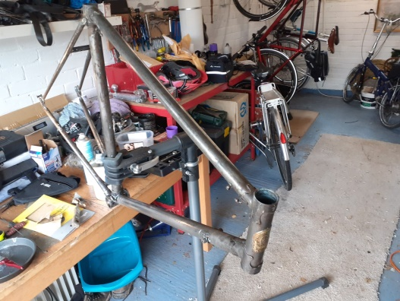
Bad Things:
1. Bikes have lots of parts designed to skin knuckles.
2. Inexpensive parts can result in a £250 spend on something worth £100. I'm good at that.
3. Things fastened tightly for 50 years often don't undo easily (more skinned knuckles).
4. The need to borrow or buy a few special tools.
5. A kitchen is OK but a dedicated space is better!
6. You meet neighbours who want a puncture fixed.
7. Discover cycling friends you never knew you had.
8. Your time will disappear.
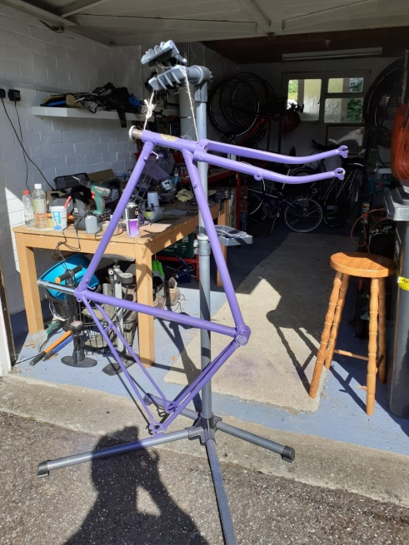
I rescued this 1956 Phillips frame and fork from a skip in April; I stripped it of paint; I resprayed it;
I rebuilt it into a single-speed bike, ready for the next 50 years of use - Easy!
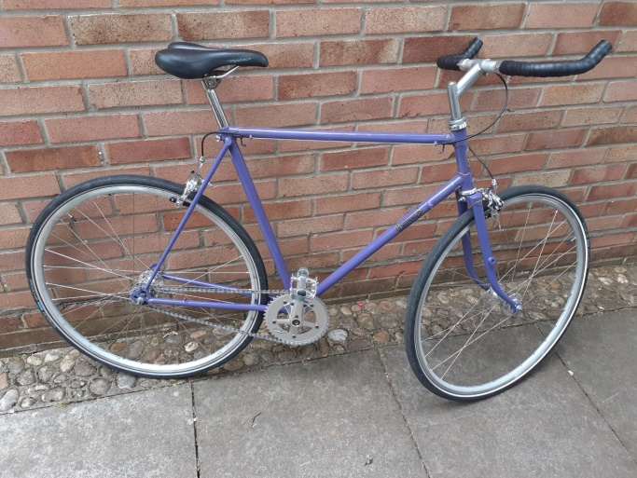
John Riches hard at it in his Workshop!

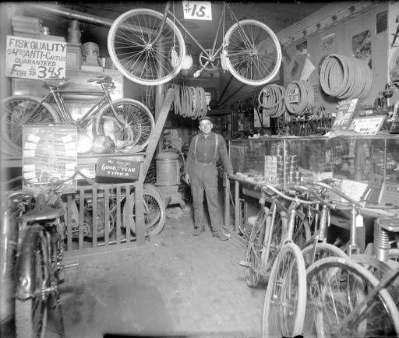

Arthur’s E-Bike Follow-up
Following lengthy research I recommend an E-Bike fit for purpose, suitable for the roads, muddy country lanes, tracks and surfaces that make up many Cycle Somerset rides, particularly when the weather is not so kind to us.
It is a bike with the right sort of vital components from renowned manufacturers with warranty and servicing agreements throughout Europe.
It will have quality, branded, components an electric motor, battery, brakes, wheels, hub gears and Carbon belt drive.
Below are two European E-Bike manufacturers with UK dealers;
https://mail.google.com/mail/u/0/?pli=1#inbox/FMfcgxwJXCFwXWSldJFxzJjcFNLBdmQW?compose=CllgCJftvBkddGHSRDBKGDDgLbvjftjXrtLmgZRfSCXwTGRFSxfnSpghzFJrlTFmbDsQmtChMHL&projector=1&messagePartId=0.1
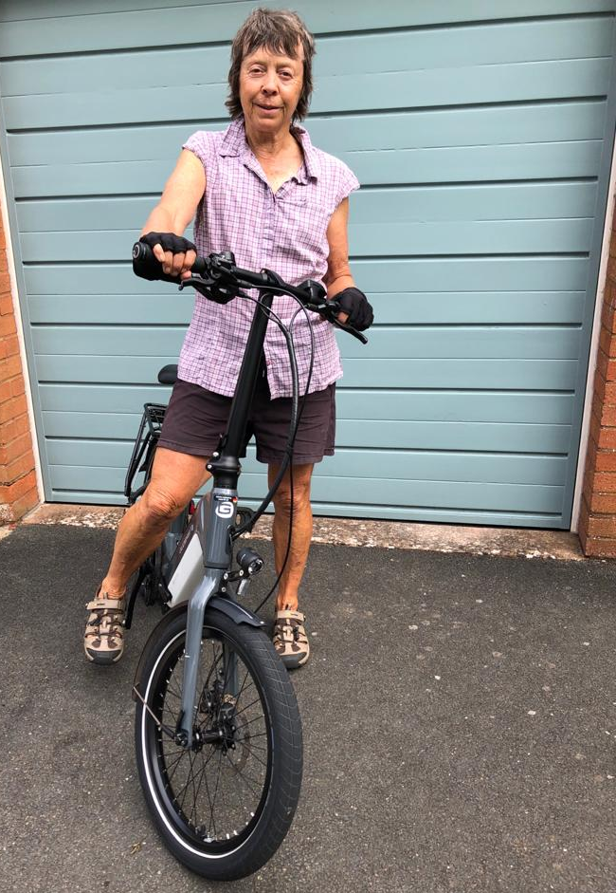
Hazel is on Gordon’s new E-bike, a Guderite “Foldo.”
Boris is Promoting Cycling to Tackle Obesity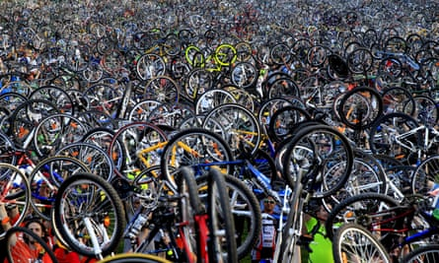
Judging by the queues, the £50 repair voucher is proving to be very popular with the cycling public!
Massage for Cyclists (Massage for Everyone)
Hello I’m Molly Brown – a student osteopath and part time massage therapist working in Taunton, I’m also a cyclist! My mum Kate is a club member.
How can massage help you?
1. It can help relieve headaches
2. Enhance immune function - Weekly massage increases total number of lymphocyte substantially, reducing levels of stress hormones (ACTH).
Twice weekly massage increases oxytocin levels (cuddle hormone), playing a role in social bonding.
3. Helps reduce non-specific low back pain.
4. Can help relieve Trigger point sensitivity (tight knots in muscles that can be really painful).
5. Is clinically proven to decrease anxiety and depression.
Please visit my Facebook page for information about types of treatments and prices.
https://www.facebook.com/mollybrownsportsmassage/
You can contact me through my Facebook page, or email me directly at brownmolly797@gmail.com
COVID update:
I’m now taking client bookings at home with a few differences… I’ve completed the COVID-19 prevention accredited course to ensure maximum safety in practice.
What new precautions am I taking? - I’ll be using a reusable face mask - Washing hands before and after each booking and asking clients to wash their hands upon arrival - Avoiding contact with clients faces - Using a disposable protective table cover - Washing towels in between appointments - Allowing 20 minutes between clients to clean and disinfect the table and equipment, fresh air to circulate - Clients to remove their shoes at the door.
What you need to do before booking - Complete a symptom checker which will be emailed to you.
Don’t hesitate to ask if you have any questions! Looking forward to seeing you soon! – I would prefer cashless payment via Apple Pay / Pay-pal.
The Watchet Tortoise
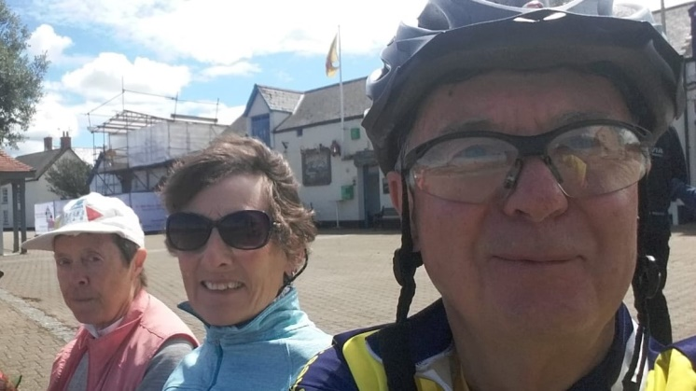
The title is the name of the ride not a derogatory comment about any of the participating riders. Above we have Peter, Philippa and Hazel enjoying the sunshine on the quayside during a welcome break, while on the, Peter led, ride to Watchet and back.
I am told Arthur is also around somewhere…I am assuming he is off tracking down a ninety-nine cone for everyone, to top-off a perfect day!
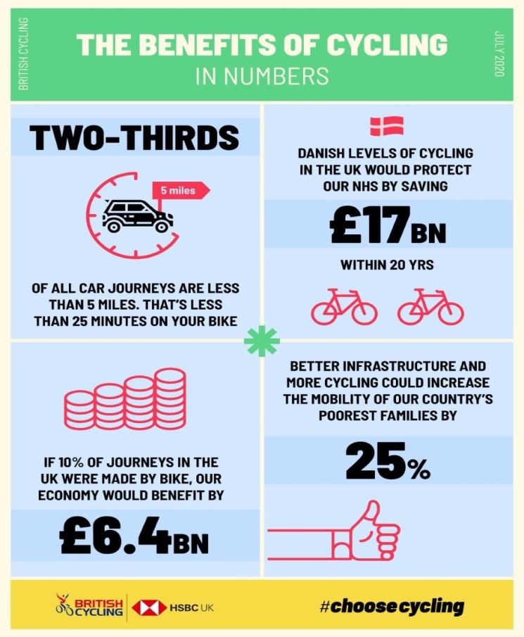
Taunton Area Cycling Campaign Report
Saturday 25th July saw a small group of cyclists gather to protest about the removal of one of the paths under the M5 at junction 25. We were concerned about the lack of space for socially distancing and the danger of crossing the southbound entry slip road. Erection of signs has made it almost impossible to view oncoming traffic. Cycle Somerset was well represented at the event, thanks to those who attended. The link to the video interviews is here- https://youtu.be/w7kVjerVnNg or members could plot J25 problems using the Somerset County Council web site https://somersetcovidactivetravel.commonplace.is/comment it will add more weight to our objections. Other problems in your own area can also be added.
There are three planning applications we are working on at present. One for Firepool includes a “Cyclists Dismount” where the new path will join St. James Street. Mike Ginger was involved in the early planning stages and has submitted an objection, citing non-compliance with Government planning guidelines for walking and cycling.
Two other applications which we are looking at and raising issues (some objections), are 1.The new Lidl Store in Roman Road. 2. Housing developments at two sites at Monkton Heathfield, all in the early stages. We are keen to get cycle parking at Lidl, it polled last in a recent survey, having no provision.
There are many other current campaign issues which are on-going and can be viewed on the TACC web site at www.thetacc.org.uk
Ideas for future editions are always welcome…
Deadline for submission of articles, ideas or photos relating to topical or recent rides: Thursday 10th September, anything of personal, local or national cycling interest always welcome.
Send to Peter Hanratty or Paul Harper:
peterhanratty@btinternet.com
paulantharper@live.co.uk
Membership: In the light of the disruption caused by Covid 19, current membership will continue until December 31st 2020 with new subscriptions will start from the 1st January 2021…hope that helps?
Changes to Cycling UK membership: Check out the proposed changes to the membership structure to secure Cycling UK's future, to be voted on at this year's AGM. Implications for membership are highlighted and too lengthy to be summarised here!
https://www.cyclinguk.org/article/proposed-changes-cycling-uk-membership-faq
Finally: “You know, bicycling isn’t just a matter of balance,” I said. “it’s a matter of faith. You can keep upright only by moving forward. You have to have your eyes on the goal, not the ground. I’m going to call that the Bicyclist’s Philosophy of Life.” ― Susan Vreeland

