Update
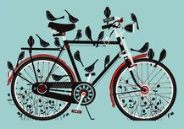
Spring is sprung, the grass is ris. I wonder where the riders is!
We are three weeks into spring and the opportunity to get out and ride is too tempting, but if your bike resembles the one above, time to dust it off, give it the once over and sign up for a ride.
We currently have 102 members…welcome to those who have recently joined, we’ll meet up on a ride soon, I’m certain.
Currently half our members ride at least once a month with 25 riding at least once, but often 2 or 3 times a week. We have 50 members who did not ride in the last month; this may be down to weather, circumstance or preference, but not lack of opportunity, we hope. We believe there are rides for everyone, but we need to hear from you if we are not catering for your cycling needs…if you let us know, we can do something about it.
Last month there were 27 scheduled rides varying in length from 20 miles to just under 50 miles, with a number of shorter routes which will become a regular feature as Twenty’s Plenty Rides!
There is always refreshed content on the club’s website. Have a look at the Ride Etiquette details, guidance for Risk Assessment…and all the useful and interesting stuff there (Thanks Richard).

Don’t forget to the club’s Facebook page, or sign up if you haven’t already accessed it.
The Cycle Maintenance sessions were very well supported. Derek and Tracey, from ‘On Your Bike’, did a great job of covering all the elements of basic maintenance. Our thanks go out to them… Derek has promised a follow-up for those interested.
Thanks also to the police who were in attendance marking and registering the bikes. If you couldn’t make the sessions there is another opportunity to get your bike registered at the New Inn Halse, free for all Cycle Somerset members, between 11am - 1.00pm on Saturday 7th May 2022.
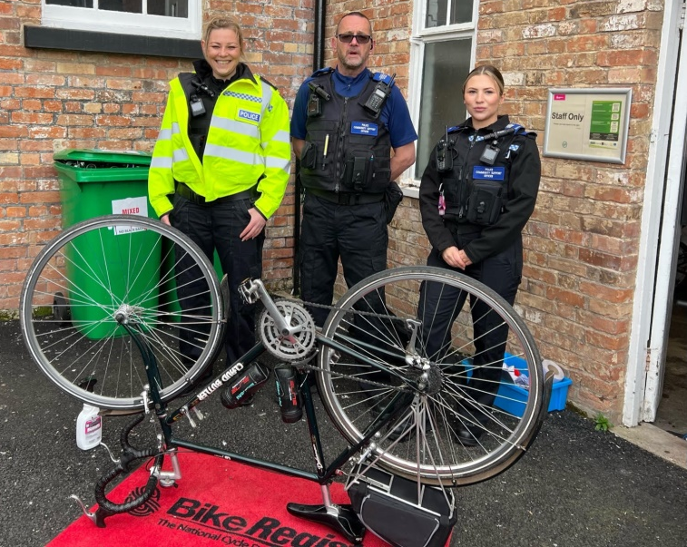
Many thanks to Sue Brooks for organising the workshop sessions.
At the last club meeting, as mentioned in the last newsletter, Etiquette Cards were discussed, agreed and are about be issued soon (detail on Web-site).
In the meantime get out there and enjoy yourself and remember what Mark Cavendish said, “To me, it doesn’t matter whether it’s raining or the sun is shining or whatever: as long as I’m riding a bike I know I’m the luckiest guy in the world”
Ride Well – Ride Visibly - Ride Safely
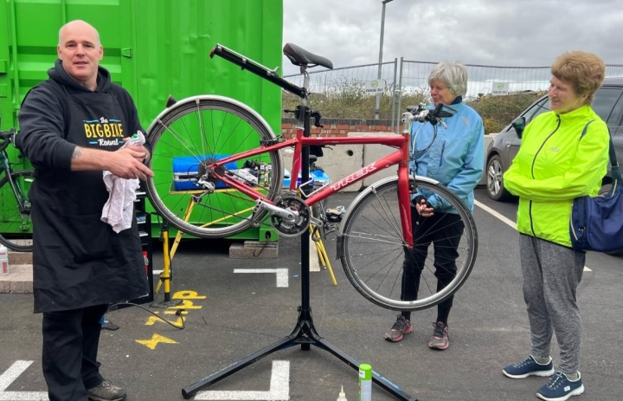As stated above the Bike Maintenance sessions were very well supported with 19 members attending on Tuesday and another 10 on the following Saturday.
Derek and Tracey went through basic safety checks, puncture repair, general adjustments to both brakes and gears, lubrication and a whole manner of other things as the morning progressed.
The workshops were very well received by everyone and a very positive atmosphere prevailed during both sessions.
They say you learn something new every day, so hands up if anyone had heard about the “One Fingered” rear wheel, removal technique? I hadn’t but it has changed my life!
Weekly Outgoings
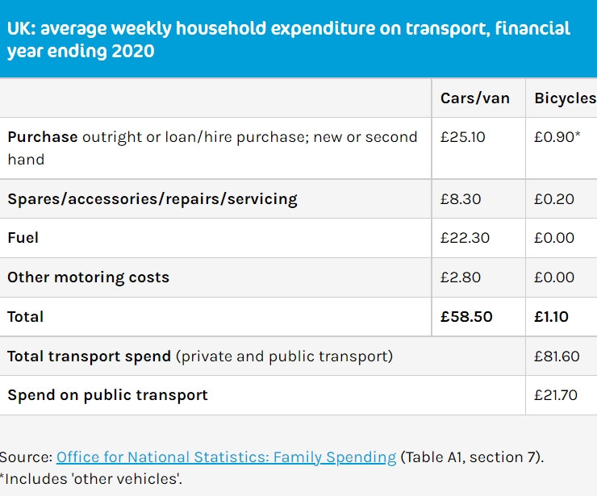
Above is an interesting table of data from the Office of National Statistics. If it proves anything it demonstrates that cycling really is a frugal way to go about your business where you can. If you look at the figure for fuel costs (Given this is from costs in 2020) you could double the figure for current costs…but the cycling remains £0.00.
Table contributed by Jonathan Sladden
Have you joined Cycle Somerset Facebook yet?
Why not join our Cycle Somerset Facebook page to share your views, photographs, bike information and fun with like-minded people. There is already lots of new content, you can add to it if you sign up.
It's a private group purely for the 2022 Members of Cycle Somerset. All applications to 'join' are checked prior to approving by the Club administrators.
Just go to the Cycle Somerset website - scroll to the very bottom of the 'home' page and press the link on the bottom right hand corner.
Sian and Sue look forward to receiving your 'Join' request which, as a member, you will automatically be granted.
Sue Brooks
Pothole Alert
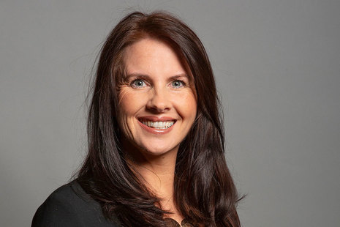
Trudy Harrison, who taught Bike-ability as a school governor, and has a degree in sustainable communities, told an All Party Parliamentary Group for Walking and Cycling meeting active travel will be key in decarbonising Britain, and cited the industry’s “significant” contribution to the economy, but she was bluntly honest about the challenges ahead, criticising cycling conditions in her home county, Cumbria, and expressing a particular desire to improve rural routes. She has said the odd white line demarcation does not signify a cycling route!
England’s new cycling Minister admits she has “pleaded” with her kids not to cycle on her local roads, decrying the state of some “terrible”, “so-called cycle infrastructure” – and says building safe cycling routes to enable disabled people, women and children to cycle more is a priority. Encouraging
Cycling Quotes 1

“Riding a bike is everything to a cyclist. The friendship and camaraderie you have with other cyclists… to a cyclist, it was the be-all and end-all of your life.” Tommy Godwin

“It is the unknown around the corner that turns my wheels.”

Heinz Stücke

New Logo WinnerThe results of the Cycle Somerset New Logo vote are as follows: WINNER - Logo No 1 above (existing logo with new colours). Logo No 2 came second the rest had relatively few votes.
Next... is to ascertain how many Members would be interested in buying a Club Cycling Jersey as there is a minimum order requirement. There will be a specific cut for Male and Female and sample sizes will be made available to members to check their sizing before they order. They can be purchased via an online shop for individual ordering by Club Members. Delivery date is between 4-6 weeks from ordering. If you are interested in buying a cycle shirt; please email me (No later than Monday 9th May 2022- susanrbrooks@gmail.com. Sue Brooks
Standby for Take Off
A new, trial, template has been added to the website allowing members to book a standby ride once confirmed places have been taken. Leaders can use it if they wish, but must keep track of the take up and liaise with another leader to provide a 2nd group ride if needed. A 2nd ride cannot be assured, the idea is to provide more places if possible.
Cafes will be advised if numbers increase or a 2nd group could contact another cafe instead. If combined numbers are 12 or less, a single group could be formed if the leader is happy to lead this.
Note: Could Ride Leaders using the Standby template duplicate the Master copy as multiple versions of spare templates for different dates / types might be confusing! Please contact me if you need help with this - Richard Sykes
SPECIAL OFFER 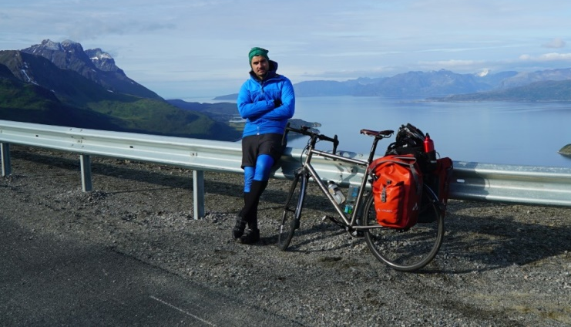The Brewhouse Theatre, Taunton - Thursday 12th May 2022 - A Night of Adventure: Cycling 3,500 Miles Around Pandemic Britain documents the 3,427-mile journey award-winning travel writer and broadcaster Simon Parker cycled around Britain during 2020 and 2021, beautifully depicted through short films, photos, audio clips, and anecdotes.
Travelling to the furthest corners and traversing the extraordinary landscapes of Britain, the talk will be followed by a Q&A with Simon himself.

Cycle Somerset has been offered a group discount – use the promo code SIMON10 on the website or at the Box Office to reduce tickets to £10 each.

Miriam Higgs, Sales & Ticketing said …..
We can offer you and your group a discount – use the promo code SIMON10 on the website or at our Box Office to reduce tickets to £10 each.

Taunton Brewhouse
Brewhouse Theatre & Arts Centre, Coal Orchard, Taunton, TA1 1JL
Tel: 01823 283244 - www.tauntonbrewhouse.co.uk

Cycling Quotes 2
Next to a leisurely walk, I enjoy a spin on my tandem bicycle. It is splendid to feel the wind blowing in my face and the springy motion of my iron steed. The rapid rush through the air gives me a delicious sense of strength and buoyance, and the exercise makes my pulse dance and my heart sing.
Helen Keller
Riding an E-Bike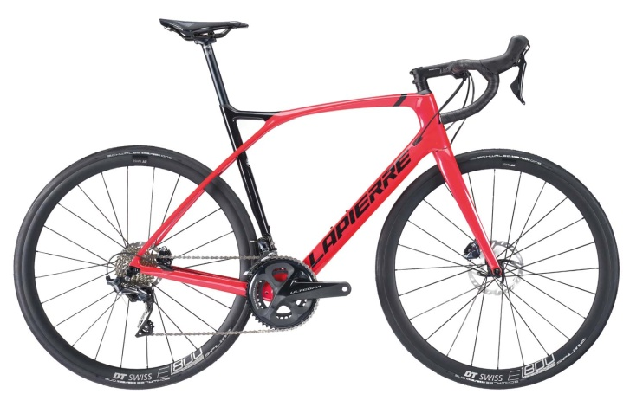As I looked through a newsletter from two years ago I spotted an article from Arthur giving members advice about any potential e-bike buy. He was very supportive and helpful giving expert advice and reassuring members they would not regret the decision to go electric… none have.
Two years on and it is rare to go on a club ride these days without one or more electric bikes in attendance. The latest development is the 'stealth' type models whose designers have tucked the battery and motor inside the frame, looking like a regular road or gravel bike. Weight is coming down, price not, so far. Above is the Lapierre model being enjoyed by Charles Smythe…very sleek!
I have to say nothing gives me greater pleasure than labouring up a challenging hill and then being overtaken, during the last few metres, by a smiling, relaxed, svelte colleague on a silent e-bike.
All Smiles at The Wharf

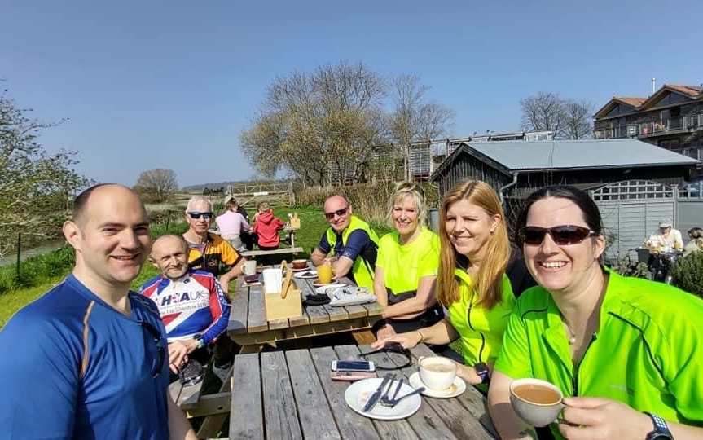

Cycle Routes – Active Travel
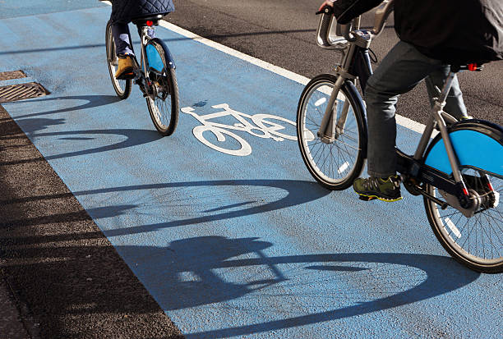
Recently there was a mass gathering of cyclists at Sheppey’s Cider in support of a cycle lane to be installed between Taunton and Wellington. Our MP claims it a long term ambition to see it happen.
At a national level, however, The Department for Transport (DfT) has been forced to reduce travel funding to a string of councils after councillors removed pop-up cycle lanes and pedestrianised areas before they had a chance to change the way people travel. Fingers crossed for Taunton-Welly!
The government’s active travel strategy states funding will be stopped if councils are “not taking active travel seriously” including removing “schemes prematurely”. A DfT spokesperson said: “We have consistently made clear to local authorities that they must deliver good quality active travel schemes, to ensure our roads work for everyone – or funding will be withheld.”
Cycling UK said too many councils were removing schemes prematurely. “Survey after survey shows active travel measures are actually popular but councillors and MPs are listening to a noisy minority first and a misinformation campaign by parts of the media,” said Duncan Dollimore from the charity. As for us locally wait and see and follow the TACC website for up to date progress reports!
Thanks to the Guardian and Cycling UK

You and Your Bike 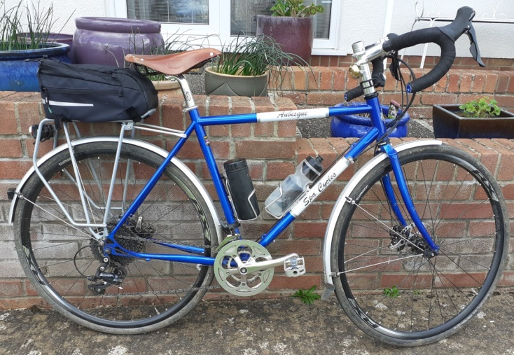Why do you cycle? For pleasure, I love being outside in the country, meeting people and enjoying the wildlife. The fitness benefits are also welcome.
How often do you go out on your bike? Most days locally and at least one longer ride per week.
Which is your favourite bike? I have three bikes and I love them all, the 1995 steel Marin I built myself and use around town; the Orro Road Bike - is quick and light and the Spa Steel Tourer - very comfortable over longer distances (pictured above).
What do you take with you? Longer rides I take water, tools, banana, debit card and energy bar.
Mend punctures or buy a new inner tube? New tube by the roadside and then mend at home.
A favourite cycling gadget? My Carradice panniers are twenty years old but still strong and useful.
What cycling tip would you pass on? Give other road users clear signs of your intentions by signals and positioning, so they can avoid you.
If you had £100 what would you buy? Some really good lights for my tourer,
What is your favourite local ride? Taunton, Angersleigh, Hemyock, Uffculme, Nicholashayne, Wellington, Taunton. What single thing would most improve matters for Cycle Somerset cyclists? Better infrastructure. The work TACC does yields big benefits for us all - John Riches
Elliptical Tales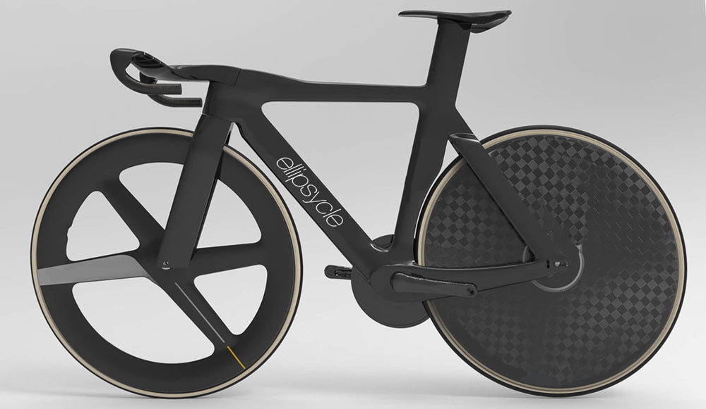Under the title 'Project Ellipcycle', researchers from Norway have discovered women's hips and pelvises benefit from the unique rotational forces of elliptical, non-circular wheels; creating greater momentum, meaning that in a competitive situation they can add 'up to 3kph' to their top speed.
Lead researcher Prof. Yüv Binadt said: "Our programme found that the hip flexors in female cyclists move and stretch in such a way that forward motion translates more easily where elliptical dynamics are part of the equation. As a recreational cyclist, I've been using prototype elliptical wheels myself through the winter, commuting around our Oslo campus. I noticed a definite sensation of greater power and stability, even on icy roads".
We will be watching how they take off with great interest. If they make you go faster, we expect their popularity to spread fast! Submitted by Karin Sladden (On April 1st)Cycling Quotes 3
“The best rides are the ones where you bite off much more than you can chew, and live through it.” Doug Bradbury

“You always know when you’re going to arrive. If you go by car, you don’t. Apart from anything else, I prefer cycling. It puts you in a good mood, I find.” Alan Bennett
Ride Safety
In the Club Website article, ‘Etiquette on Club Rides’, a key point is to ‘pass messages up and down the line to warn of hazards’.
When group cycling, communication is the key to everyone’s safety. The ‘leader’ and ‘back marker’ shout out potential hazards, but it is vital for everyone to pass messages ‘up’ and ‘down’ the line, including all hazards ahead… or behind. Shout outs below:
‘CAR BACK' Traffic is coming up behind the group.
'CAR UP' Vehicle behind a group is coming through.
'CAR DOWN' Car from the opposite direction and riders need to keep tight on their side of the road.
‘LOOSE’ indicates a loose surface, gravel or chippings that might cause loss of grip. Sometimes you may want to be specific and shout ‘GRAVEL’.
'SLOWING’ warning to everyone to slow down – for whatever reason; Give Way, Junction or the ride leader giving stragglers the chance to catch up.
'CLEAR' when turning is an indication that the road is completely clear in both directions.
'CLEAR RIGHT' when turning left, indicates there are no vehicles approaching from the right so a turn is possible. PLEASE NOTE: 'Clear' only means at that moment. All shouts are for guidance, things can change quickly and clear now might be the opposite when you reach the junction.
'STOP' is a command to stop at the junction for whatever reason… traffic or hazard.
'PUNCTURE' and 'MECHANICAL' are shouts to warn riders behind you may slow down or those in front you intend dropping off with a problem.
‘HAND SIGNALS’ sometimes a shout is necessary, however hand signals may be used to indicate hazards or recommended actions to those behind.
i.STOPUniversal signal to halt
ii. SLOWING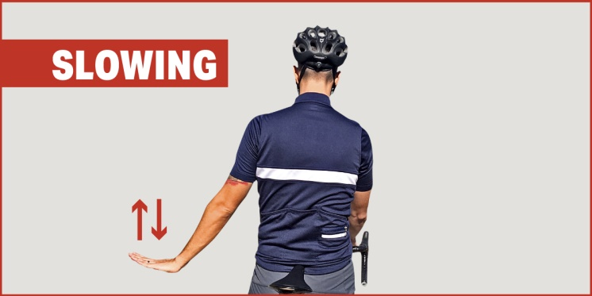It’s always a good idea to alert those behind you when your speed begins to decrease.
iii. TURNING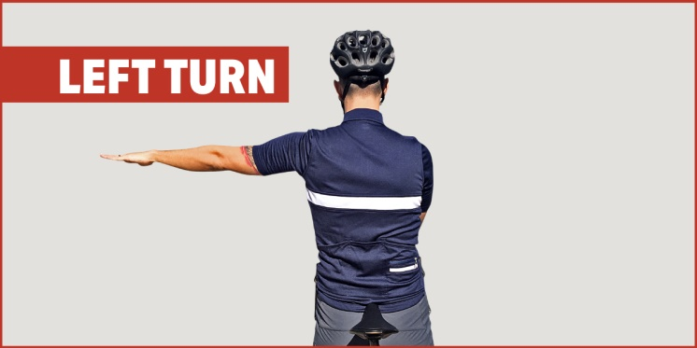Turning left (or right – opposite arm), or changing lane a simple guide to all road users.
iv. POTHOLE
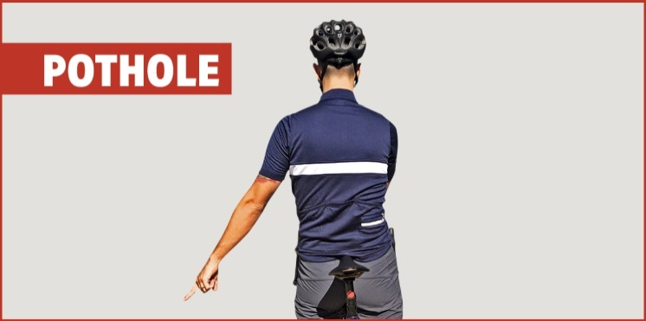
A pothole has the potential to cause an accident. Point out a pothole that shouldn’t be ridden over.
v. DEBRIS
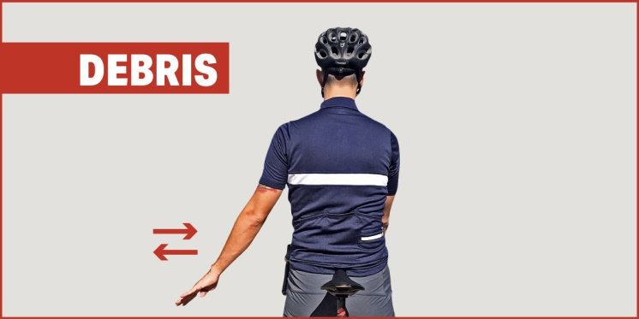
Dirt, gravel, or loose debris on the road might cause you to lose traction, signal to all trailing cyclists.
vi. MOVING IN OR OUT
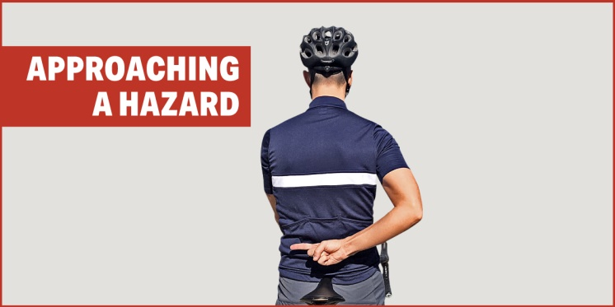
A rider pointing or waving behind their back is indicating that riders behind should move out (or if mirrored, in) to avoid a hazard…pedestrian, parked vehicle, slower cyclist or on-coming vehicle etc. Thanks to Paul Lewis for modelling the hand signals
I sincerely hope you find these useful and continue to enjoy safe cycling throughout the Spring and Summer months with your cycling buddies.
Keep Safe. Sue Brooks
Cycling Quotes 4
“It’s a risky business being a cyclist in the UK, there are a lot of people who really dislike us. It’s the Jeremy Clarkson influence — we’re hated on the roads. We just hope people realise we are just flesh and bones on two wheels.”
Victoria Pendleton
Up High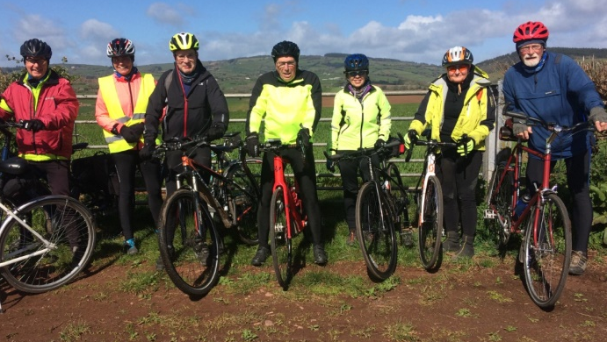Near before HoccombeColombia Es Pasion!A brilliant book by Mat Rendell about the rise of Colombian cycling and how champions are made:
Nairo (Quintana), aged fourteen, set aside enough money to buy an old mountain bike. Offering him something hard to come by in a peasant world of limited possibilities, a means to a kind of self-realisation, and he came to regard the bike as a close companion, almost human. He coasted down the 16.5 kilometres to school and then rode back up again. From then on he didn’t take the bus; thus history was in the making, cycling twenty kilometres a day, at altitude and the start of little races that swiftly brought local, national and world renown!
Mona Lisa
Leonardo Da Vinci went to his grave lamenting his sponsor’s order to omit his beloved Colnago Road Bike from the finished painting. He fully accepted it was a mystery, the lady had an enigmatic smile and he had captured something magical; but he always felt adding a lightweight frame and a full set of Campag Gears would make it a much more commercial picture!
Meet Up at the Brewhouse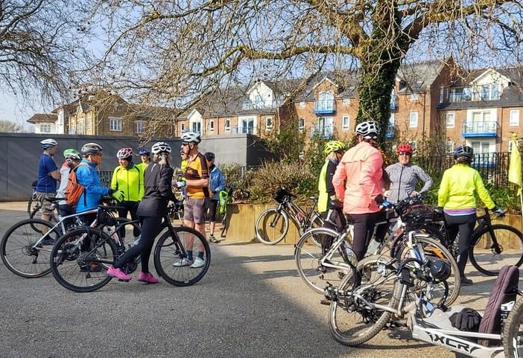
Anyone round here know where we are going?
St Margaret’s Hospice Ride
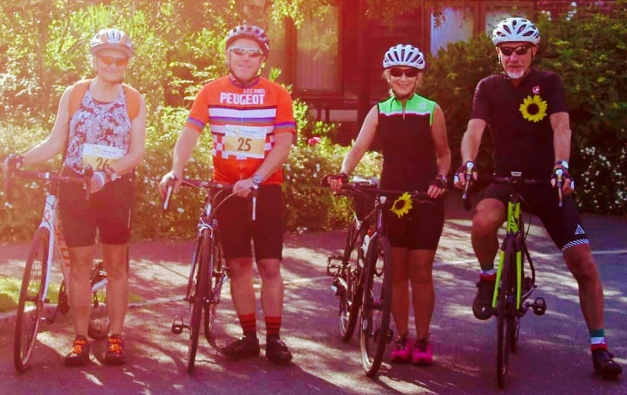
St Margaret’s Hospice is on the search for keen cyclists to take part in this year’s Charity Cycle Ride in April. It is on Sunday, 24 April with a brand-new route with two distance options, taking cyclists through beautiful Somerset scenery. The popular event will see participants tackle either the epic 100-mile circular route starting at our Yeovil Hospice or the 35-mile route starting at the Taunton Hospice with both routes finishing at the Yeovil Hospice where cyclists will be joined by their supporters for finish line celebrations.
Participants will enjoy cycling through beautiful Somerset villages and towns including Glastonbury, Burrowbridge, Montacute and Shepton Beauchamp with supporters cheering them on along the way.
Entries are still open for the pedal-powered challenge with places costing £30 for any distance, cyclists will enjoy regular feed stations, mechanical support, event photography and professional first aid cover as part of their registration fee.
Last year, the event raised over £15,000. Riders are encouraged to raise sponsorship for St Margaret’s, which helped the hospice care and support more than 5,000 people affected by a life-limiting illness across Somerset. By raising £100 each cyclist could pay for a specialist community nurse to visit a local patient at home. It’s not too late to sign up!
Pictured above, the Crowfords and the Harpers on last year’s ride.

Get a load of the rivets on that!
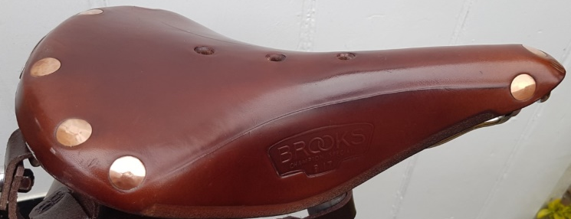
Brooks’ Saddles are like Marmite... I own three, so it is obvious where my sentiments lie. The great thing about leather saddles is they get better over time, gradually conforming to your lumps and bumps. Brooks have been making leather masterpieces since 1878, the machines have been in use for almost a century! Each seat differs slightly from any other and one of my saddles seems to be made of stiffer leather than the others. Wisdom says honey coloured saddles break in quicker than black ones, but I haven’t noticed a significant difference.
The Brooks B17 standard is the biggest selling model in the range. My latest is a “new old stock” B17 “Special” and seems to have a more robust hide, with legendary oversized hand beaten copper rivets and hand chamfered edges. Monica loves her honey hued saddle; it is shorter and wider than the B17 and has transformed her riding experience.
They need looking after so cover them if left outside, applying regular doses of “Proofide.” As the saddle stretches, tighten the slack on the thread under the saddle nose using a Brooks spanner. All the long distance old timers ride on Brooks saddles. Hang on a minute I’m 75, so I am an old timer too!
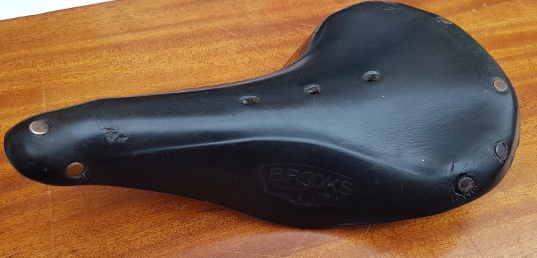
Martin Atton
Spot the Difference
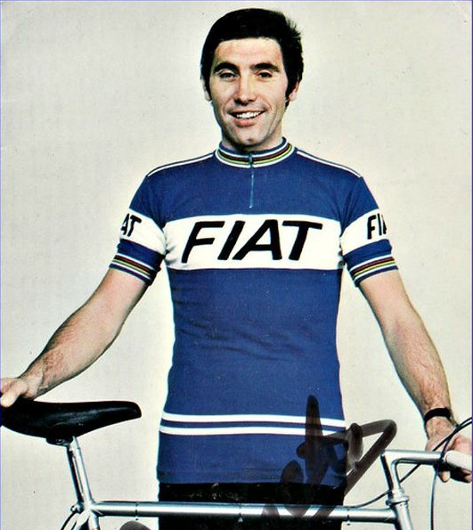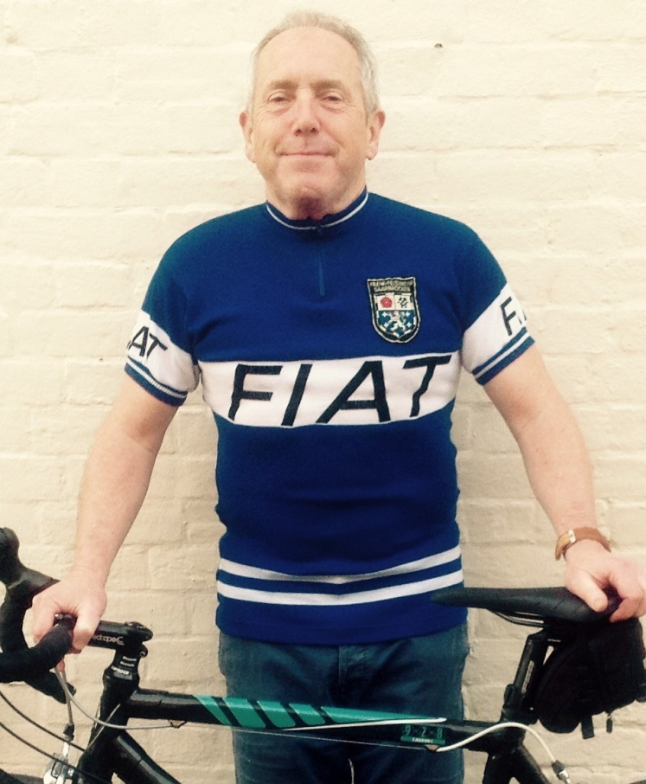
This month’s competition:
There will be a bottle of wine for the first correct e-mail entrant who spots the five differences between the two pictures of Eddie Merckx, above.
Wivey Wander
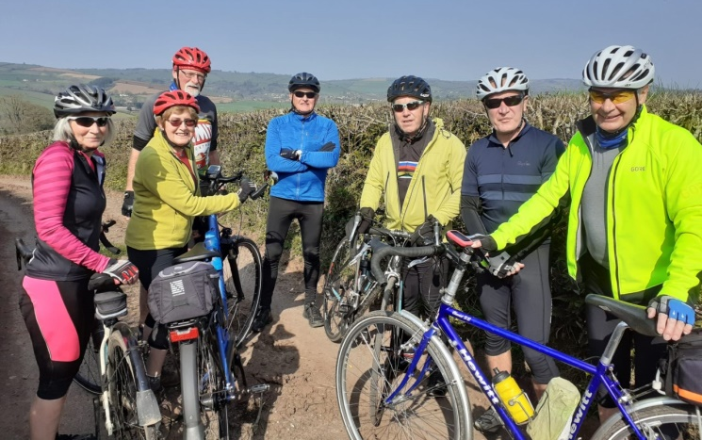
Old Friends and New Friends at the New Inn
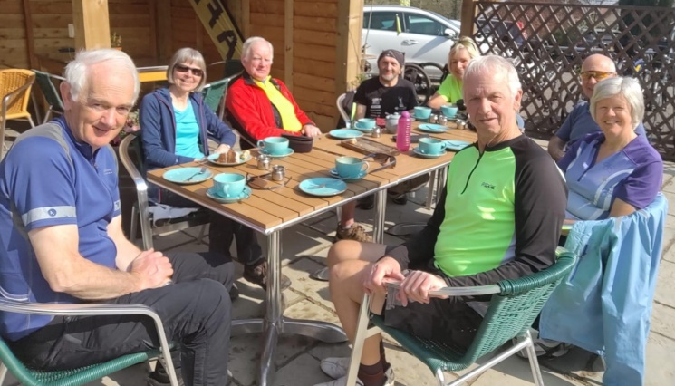
And finally… They say Cycling can grow your brain in the same way it can grow your muscles and riding can increase the production of proteins used for creating brain cells by two or three times the norm! In that case by the time the next newsletter comes out, regular riders will have done better at answering the questions on The Chase, Eggheads or Countdown. Just a thought!
Ideas for future editions are always welcome…
Deadline for submission of articles, ideas or photos relating to topical or recent rides: Thursday 19th May, anything of personal, local or national cycling interest always welcome.
Send to Peter Hanratty or Paul Harper:
peterhanratty@btinternet.com
paulantharper@live.co.uk

