A Cycling Life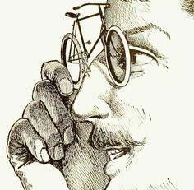You know you have it bad when you view all things through a spoked lens; news is measured against the impact it will have on cyclists and the weather forecast for Tuesday suggests we’ll have a rain free ride. Birthday cards pick up a cycling theme, not to mention the socks chosen because they have a mounted cyclist logo! It’s a blessing and a curse!
However, the weather has been good, the number of rides impressively numerous, the destinations are near and far and some are exotically far flung! Ride leaders have also promised to include more details when they post rides to ensure members can gauge the level of challenge…so all good!
Is it me or are we getting a great reception wherever we stop for coffee? I think we are beautifully prepared for a glorious summer of cycling…look out for a ride to suit you and keep your eyes peeled for some exciting, up and coming, activities for club members. Ride safely. Cycling Quotes 1: “My two favourite things in life are libraries and bicycles. They both move people forward without wasting anything. The perfect day: riding a bike to the library.”
Peter Golkin, NASA scientist

The Handlebards
Join The Handlebards in the Castle Gardens, Museum of Somerset for a bicycle-powered, production of Twelfth Night. Thursday 23rd June, 7pm – 9pm. Reduced cost (£17 not £18) if booked via Karin (link). Confirm by 25th May.
Duke Orsino loves Lady Olivia, but she won’t have anything to do with suitors. Viola is shipwrecked believing her twin brother Sebastian to be dead. Meanwhile, a bunch of Olivia’s servants plot to make a fool out of her pompous butler, Malvolio. There’s drinking, frivolity and cross-dressing a plenty.
This is an outdoor production, so please bring your own chair or blanket to sit on, a picnic to dig into, and dress for the weather! Doors open at 5pm so bring a picnic and come and enjoy the beautiful surroundings. (the performance starts 6pm) Chairs, picnics, blankets and any other low level accessories are welcome. In case of rain please don’t bring umbrellas as they block sight-lines for other audience members. Ponchos and raincoats are just as fetching, so please wear these instead.
Short and Sweet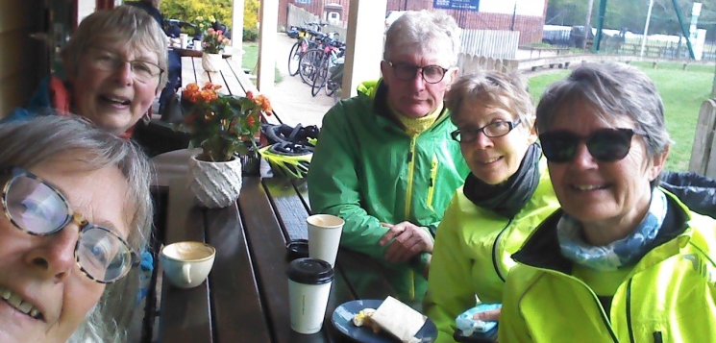
…with friends
Vive La France
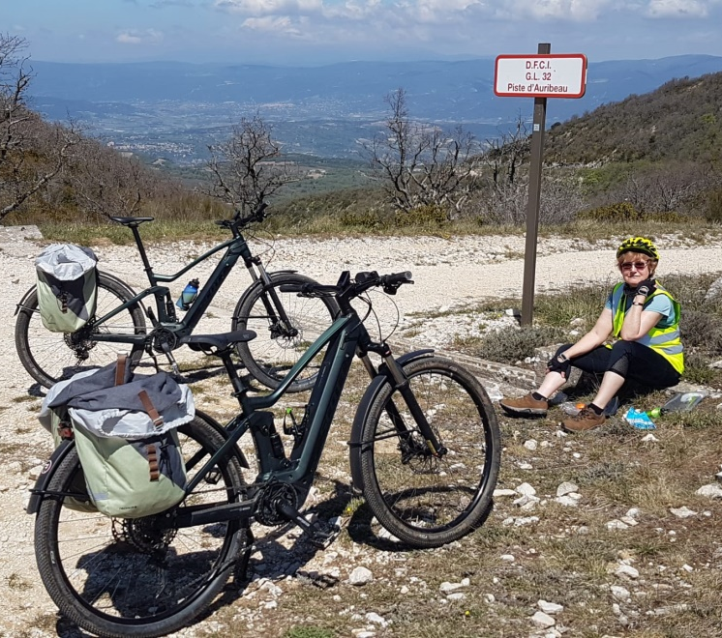
Monica and I have returned from three weeks in Provence, south of the wooded 1100 metre high Luberon hills near Aix en Provence. We have spent several holidays in the region, as we combine visiting Monica’s son and his partner while taking the opportunity to cycle around a beautiful area. We stay in the sleepy village of La Bastidone, and rent a Spartan, spacious flat next door, run by a lovely lady originating from Southern China.
We hire E-bikes and ride around the local villages, enjoying the unique ambience of the area. The scenery is spectacular and the weather wonderful this time of year, so much more comfortable than the scorching temperatures of mid-summer. Most days we plan a route and set off first thing to the nearest local town to source the ingredients for lunch with a large baguette taking centre stage. We then stop at a village bar and enjoy a welcome coffee. Our Al fresco lunch is enjoyed under bright blue skies, with fabulous views afforded by the panoramic vistas and spectacular limestone terrain. The Luberon hills to the North form a transverse broad ridge, with three passes over the massif, negotiable by wheeled vehicles. We rode our E bikes over two of them, the first, a rubble strewn fire track masquerading as a highway. Fortunately our steeds had suspension and large section tyres. At this col, we should have been able to enjoy a grandstand view of Mount Ventoux to the North, and site of many Tour de France battles, unfortunately in the accompanying picture, the mountain is completely shrouded in cloud. Cest La Vie! At only 1900 metres high and appearing to have gentle slopes it looks relatively benign. This of course belies the fact that the summit climbs are over 20km long with the upper slopes blasted by the sun bouncing off the white limestone terrain, adding a surreal quality to the place. Our second foray provided a complete contrast, as the climbs and descents were on smooth tarmac round sweeping bends. The road down from either side of the col will feature as two of my “Desert Island” descents!
One lunch time while consuming an excellent entrecote by a local lake, we noticed ominous clouds gathering, so beat a hasty retreat to try and get home before things deteriorated further. Less than ten minutes later, the heavens opened for a downpour of truly biblical proportions, worse than a monsoon I experienced when travelling through India! Immediately the roads were 10 centimetres deep in floodwater, we were also briefly subjected to a battering by marble sized hailstones! We couldn’t stop, as trying to shelter would have rendered us hypothermic, plus the risk of being struck by the lightning, forking all around us. Things got serious, when a massive flash forked down on the road in front of us, followed by a deafening thunderclap. Scary, but totally memorable!
Luberon national park offers wonderful cycling, the roads quiet and the weather superb. The caveats I would add; Ride an E-bike unless you are into serious masochism and stay clear of July and August to avoid heat exhaustion. Provence is such an attractive proposition when choosing a holiday destination, an area to be recommended!
Martin and Monica
Abbey Road 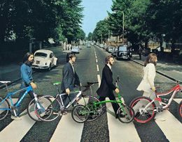There are many photographs of the Beatles riding bicycles but they are nearly always pictured astride a sturdy, steel, steed like the Raleigh Superb Roadster or, the Humber Royal Elf or a Triumph Roadster. The poetic licence observed by the above mock up suggests a sense of humour! Paul and John are both pushing Road Bikes, Ringo is safely commuting about town on his Brompton and John is heading for the wilds on his mountain bike…once they have finished recording the Abbey Road LP!
Save Money… save the Planet
Cycling Quotes 2: “Every time I see an adult on a bicycle, I no longer despair for the future of the human race.”
H .G. Wells, English Writer
Uphill like a Rocket / Rabbit / Robot / Rickshaw*
The best 7 tips to cycling uphill: i. Don’t race at it, avoid going into the ‘red’ too early on the climb. Don’t get carried away on the lower slopes, if you still have a long slog to the top. ii. Maintain a reasonable cadence of 65-80 rpm. It will be a lower cadence than normal, but avoid pushing a big gear at a very low cadence. iii. Anticipate steep sections in advance by getting into lower gear early. iv. Traffic permitting, avoid the steepest apex and go wide around corners to maintain the best rhythm and constant speed. v. If possible remain seated. Save standing on the pedals for really steep hills and steepest sections. vi. Stick to your own pace. It is counter-productive to try and stay with much quicker riders. You will lose more time in the long run. vii. It helps to know what you are climbing – length, gradient, max gradient, and likely time needed. *Delete where applicable
The Queens Platinum Jubilee
It was decided at the last club meeting to hold an event on Friday 3rd June to mark the jubilee. There will be a cycle Treasure Hunt, based at Dares Farm, Stoke St Gregory. The format will be to assemble for coffee at 10am (parking available for those that wish to drive or plenty of room for bikes if cycling!). Teams of up to 5 will be given a circular route and some questions/clues to find along the way. Some will be short, others longer so that you can choose the effort you wish to expend. It is anticipated teams will complete 2 or 3 routes with a break for lunch when it is convenient. The event will finish by around 3pm.
An invitation will be posted soon.
Graham
Cycling Quote 3: “Get a bicycle. You will not regret it; if you live!” Mark Twain, American Writer & Humorist
E-bike Observatiions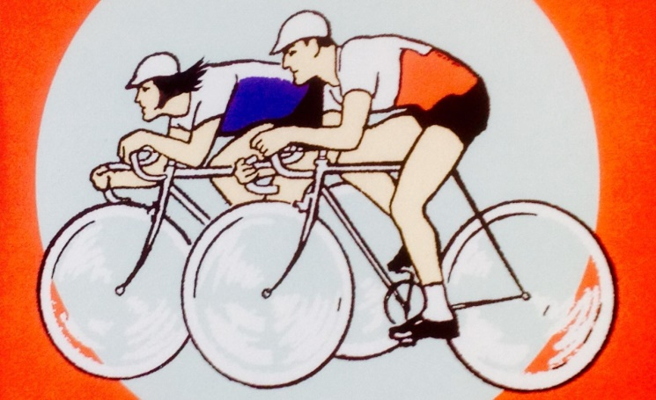Hi folks, I had to muse over a couple of things from the last ride. Ali reckoned she needed 40% E-power to equal the effort on her conventional bike and Lisa bantered that I did not need an E-bike. These are linked and this is my theory provided your E-bike is heavier than your recent conventional one.
In this observation, E-bike means the 250 Watt motors either in the rear hub or crank of a road bike, not the heavy Bosch type which tend to have E-power on constantly to compensate for weight.
Firstly, everyone with a new road E-bike seems to be going down the learning curve that I did when group riding i.e. only using E when the incline dictates. This means we are keeping up with those on conventional bikes but working harder most of the time due to heavier bikes. This is good as our fitness levels are getting better and like me, after a few months you will find your conventional bike seems relatively feather weight and a joy to ride which is why I am happy with my old Scott on a Levels ride.
This also means that Ali will probably find that 30% will eventually do the trick and Lisa’s banter turns out to be Catch 22 i.e. I now don’t need an E-bike because I have been riding conventionally with you on a heavier E-bike thus working harder and getting fitter.
What do you think? Chris Gill

Ray Sharpe
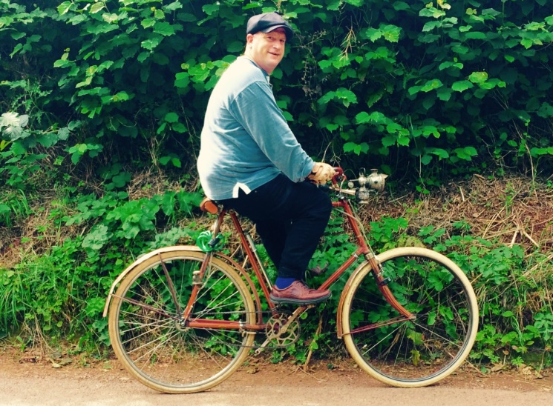
A year ago almost to the day (You may remember this picture) we bumped into Ray Sharpe and lo and behold on our ride to Fyne Court, in almost the same place as we did before, we bumped into him again! Ray is still riding up from North Petherton to the top of the Quantocks along his favourite route. He continues to ride his 1903 Hercules cycle with its early 3 speed. Good for you Ray and, if my maths is good, we will meet up with you again in May 2023.
Short and Sweet
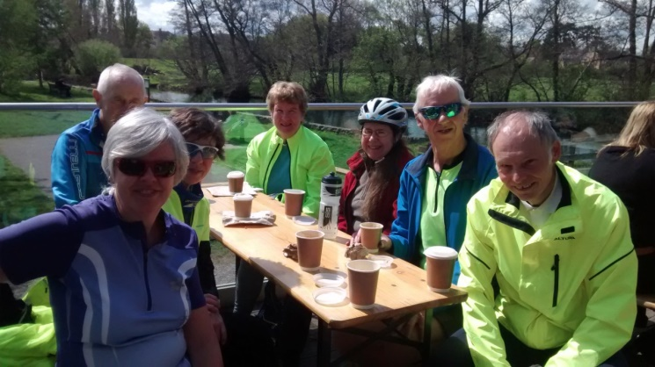A local classic
Cycling Quotes 4: “The bicycle has a soul if you succeed to love it will give you emotions that you will never forget.”
Mario Cipollini, Italian Road Cyclist.

Me and My Bike
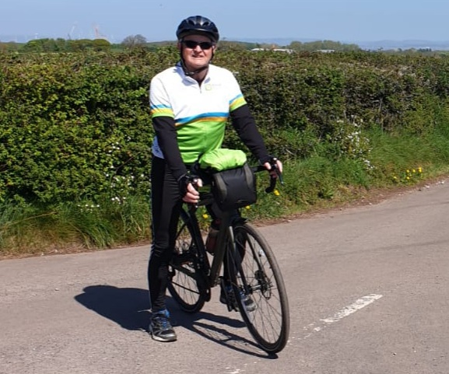Why do you cycle? I cycle for the company of fellow riders and to keep fit.
How often do you go out on your bike each week? I ride 2 or 3 times a week.
Which of your bikes is your favourite? See photo!
What do you always take with you when cycling? The right clothing (mostly!), toolkit, phone, spare cash, members list if leading.
Do you mend punctures or buy a new inner tube? I repair at home but replace a tube on the road.
Your favourite cycling gadget? My phone app.
What top cycling tip would you pass on to others? Progressively increase the length / amount of cycling you do if you want to enjoy longer club rides.
If you had £100 to spend on cycling, what would you buy? Deposit for cycling holiday in Italy.
What is your favourite local ride? Don't have one. It's a combination of the weather and company on the day as well as the route and coffee stop for me.
What single thing would most improve matters for Cycle Somerset members? More participation across the board, cycling, planning, leading etc. Richard Sykes
Well I Never…
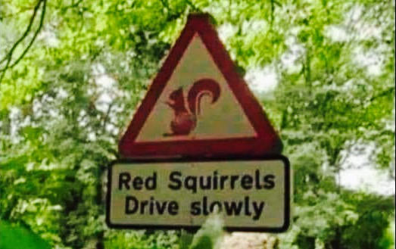Who suspected that?A Fyne Set of Cyclists
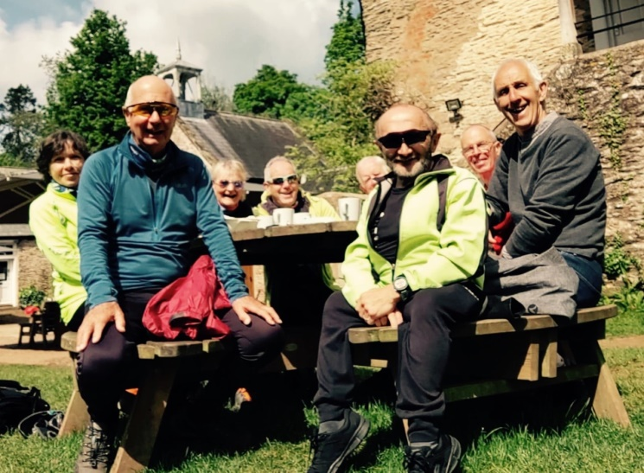Dave’s photo stick gets around!
Live Crocodiles…really?
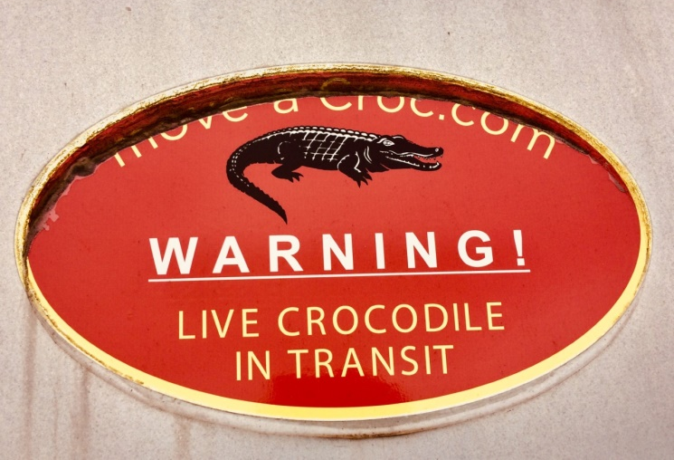Spotted neer Creech recently, should there be an escape, cyclists are advised to make a snappy getaway!
Bike Bath The above looks exciting; a choice of 3 rides around Bath and a host of interesting sights and views.
As an entrant to Bike Bath, you benefit from: i. Fully waymarked routes with a back-up route map and GPS files; ii. Feed stations on the long and medium routes; iii. On-course first aid and mechanical support; iv. A medal at the finish line. Supported by Bath Recreation Limited and the wonderful VC Walcot.
The partner charity for 2022 is Dorothy House Hospice and we welcome all charities to enter teams and you can see below the large number of charities who have participated in the past. Start times: 75 mile route (all locations) 0730-0830
50 mile route (all locations) 0830- 0930
26 mile route (all locations 0930 – 1015
Paul and Mandy Harper have signed up for the shorter route if anyone wants to join them. Cost for entry, £25 for the short ride £35 for the others.
Parchey Bridge Ride
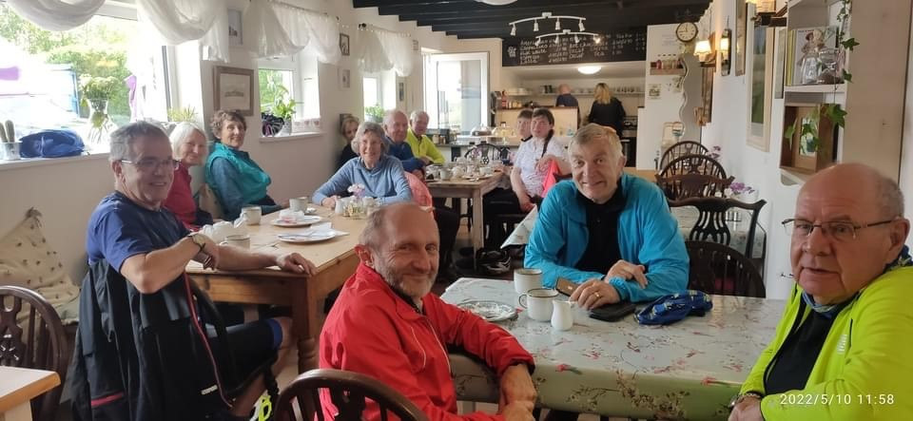
A welcome coffee and a chance to check if Steven still has both compulsory wheels on his bike!
Westhay
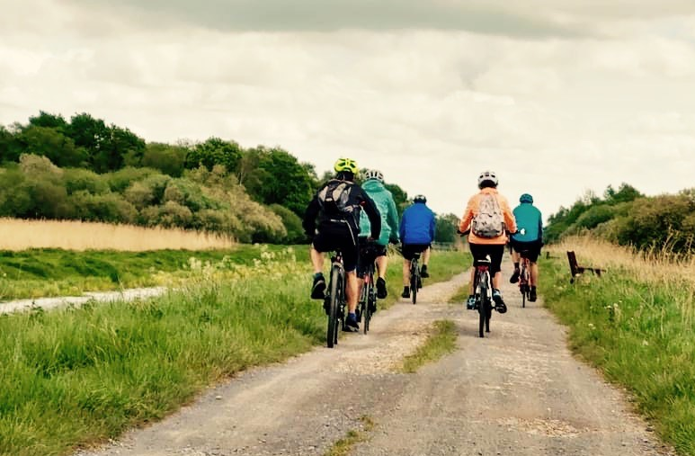
Cycling Quote 5: “When I go biking I am mentally far, far away from civilisation. The world is breaking someone else’s heart.” Diane Ackerman, American Poet
Seen any Crocodiles?
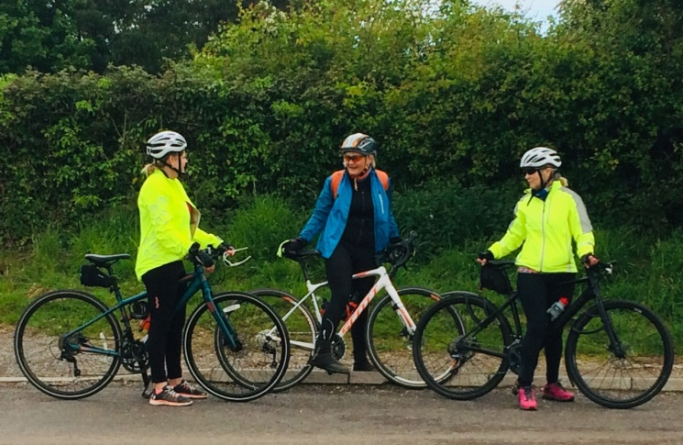
Cycle Photograph of the Year?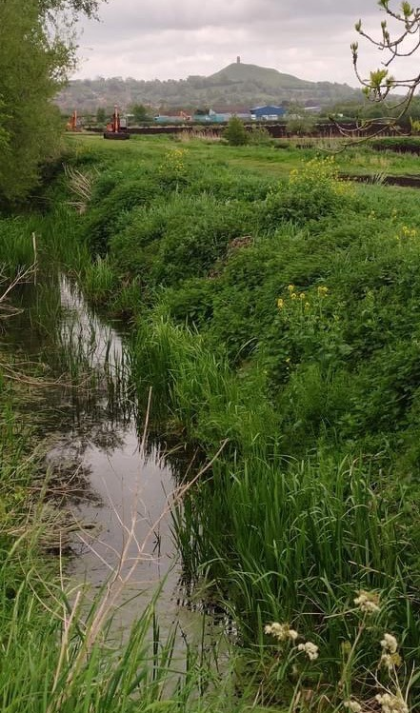The Next Bike?
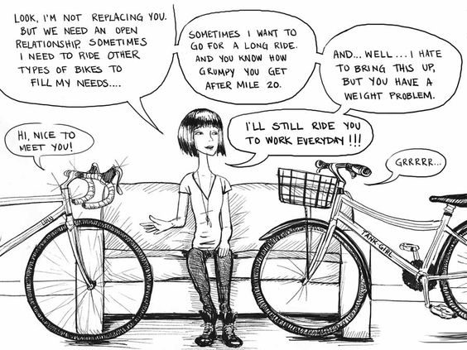

Taunton – Welly Cycle Path
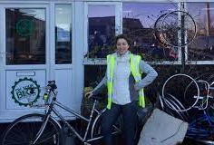The dream of a cycle path between Taunton and Wellington is still alive and with Rebecca Pow’s petition adding momentum!
Ms Pow has said it has been a 'long-held ambition' of hers to have a cycleway along this busy route. "Crucially this would make cycling along this route safer, encouraging more people to get out of their cars and onto bikes thereby reducing pollution from vehicles but also it will help to bring obvious health and well-being benefits to those cycling," she said.
"There will be spin offs for local businesses as data indicates that cyclists are more likely to shop local. A vital link could also be made with the proposed Wellington Rail station. It makes sense to develop a cycleway that will also access the new station."
Following the W2T rally Rebecca Pow/Mike Ginger encouraged cyclists to sign the petition supporting the initiative. At the EAT festival TACC were also encouraging the public to sign. Ian Bright, club member, is heavily involved and providing details / link to Club Facebook Page. Pow’s intervention is helpful but she needs to acknowledge and continue to work with TACC and the other key groups who have combined their efforts to maintain the pressure for this scheme to reach fruition.
Health and Safety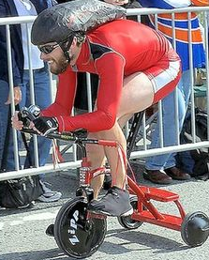
A recent club e-mail prompted members to familiarise themselves with the updated Ride Leaders information on the Club website, specifically under 'Planning and Leading a Ride'.
In addition, it was agreed, at the last monthly meeting held on Wednesday 4th May, Ride Leaders would inform the Club Secretary, by email, (Susan Brooks) of any minor 'incidents' that occur on their ride. Three recent 'incidents' were reported this month of cycle members being hurt i.e. cyclists being affected by potholes, drains and surfaces.
Should you be required to file a report, please include date/where incident occurred, who it affected, outcome and of course your Ride Leader name. The information will be recorded and discussed under the 'Health & Safety' section on the Agenda at each monthly meeting. This may seem a little onerous but it is vital we keep a record of any incidents that occur.
Many thanks for your help. Sue Brooks - Secretary
Frank Zappa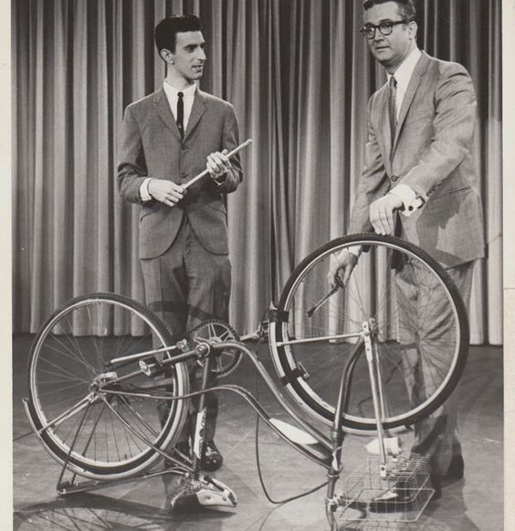…shows a TV host how to mend a puncture on the mother of all inventions!
On the Social Side
There will be a ‘Bring & Share’ event, on Saturday 16th July 2022. Phillipa has kindly offered her premises to hold the event. Cycle Somerset members to bring food which can be shared with their fellow cyclists.
Volunteers welcomed to help with the event. Details to follow soon; put the date in the diary!Halberton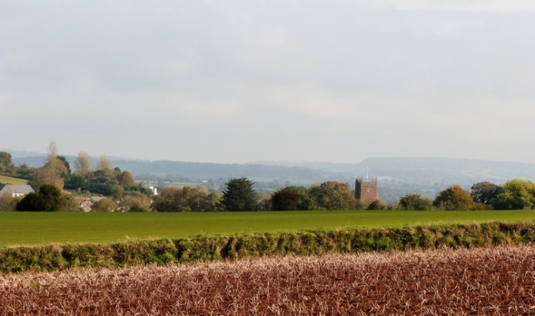
…is a lovely cycle if you know where you are going!
Ideas for future editions are always welcome…
Deadline for submission of articles, ideas or photos relating to topical or recent rides: Thursday 9th June, anything of a personal, local or national cycling interest always welcome. Send to Peter Hanratty or Paul Harper:
peterhanratty@btinternet.com
paulantharper@live.co.uk
Cycling Quote 6:
“I relax by taking my bicycle apart and putting it back together again.”
Michelle Pfeiffer, American Actress
Finally: National Bike Week will run from 6-12 June 2022 and it would be good to participate.
As a club we are already, firmly, based in our locality and the theme of Bike Week is all about community. We are being encouraged to get out there and enjoy our area by bike which I am sure we can do. We are challenged to imagine how our community can be improved if everyone in it uses their bikes more. Let’s see if we can get a record number of members out for a ride that week.
Our growing membership numbers prove the upsurge of interest in cycling and the many people who recently took up cycling or rediscovered it continues apace. Some cycle for exercise, others for commuting to work, visits to the shops or just to be able to see friends and family. Whatever the reason, we know the bike can grant everyone a degree of freedom; how to travel and how to live a fitter and healthier life.
So this National Bike Week, from 6-12 June, let’s get together and celebrate cycling and we’ll make sure there is a ride for you. Keep an eye on the postings! We are off to Holland for a week, news of that in June’s edition of the newsletter.
Please Cycle Safely

