Introduction
February has seen the levels flood, be drained and flood again. The abundance of snowdrops, daffodils and crocus blooms are evidence that spring is just around the corner. Talk of heated gloves and socks has diminished during this month and they will soon be put away for the summer!
A number of items were discussed at the recent committee meeting and those of importance are mentioned below. The minutes of the meeting are on the website.
Rolling Membership has been introduced on our website whereby membership renewal will be one year after your previous subscription payment. The system will send out a reminder one month before renewal is due where you will be asked to confirm your contact details to the Membership Secretary and to make a payment. If the renewal form is not completed, nor the payment made by the renewal date you will come off the "current members" lists and thus not receive e-mails for rides, Newsletters, etc.
Cafes and Routes:
To keep these as up to date as possible, any website changes e.g. “Riverside Café at Ilminster now closed” - forward to Paul Ewings.
All groups now start with “Current” and adding the appropriate title will select all members in that group i.e. Current Members for all ride notifications.
Curry Rivel to Langport Cyclepath Update
Cycle Somerset made a contribution to the group trying to get an off road cycle route. They report:
1st February 2024. Breakthrough
In just one week and thanks to a fantastic effort from our team of volunteers (they know who they are), we have managed to cut through the huge amount of overgrown scrub, dead trees and undergrowth so that there is now clear light from the Drayton turnoff to the first house on the main road at Sandpits.
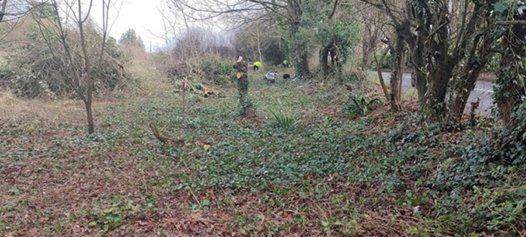
This is an incredible achievement by our volunteers many of whom have stepped forward to contribute to a project that will have lasting significance.
Work will continue to clear the remaining scrub and we are now seeking assistance in the form of machinery that will be able to remove the piles of cut stuff away from the path and also to begin the excavation of the path.
Visit to the County Classics Motor Museum
Arthur arranged an event for a party to visit the Motor museum on Tuesday 30th January. After coffee and a spot of lunch the owner Pat Hawkins gave us a short talk about the Museum and how it came to pass.
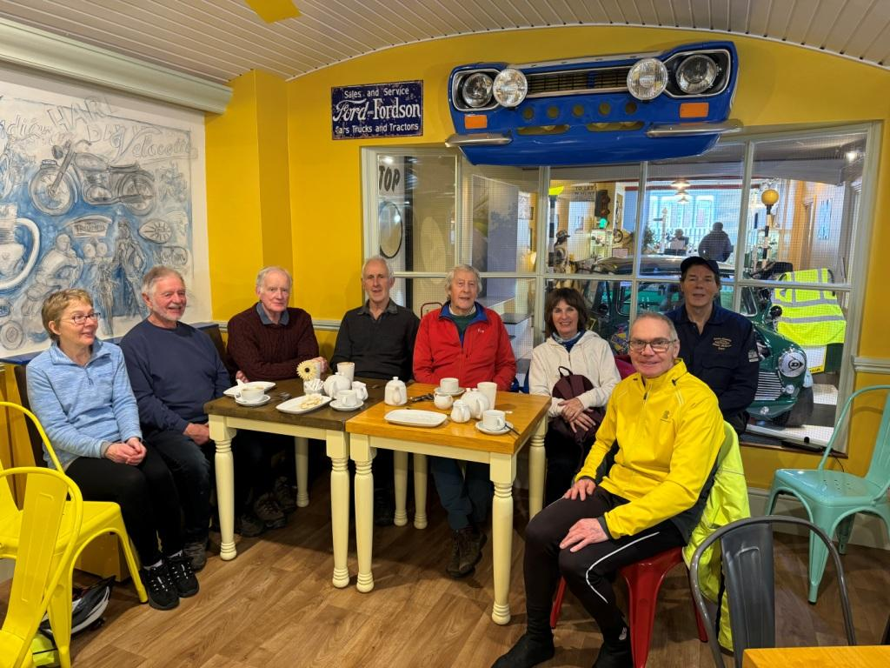
The party them toured the exhibits of 102 cars and 80 motor bikes. The building is rather like the Tardis as it goes on forever over 2 floors.
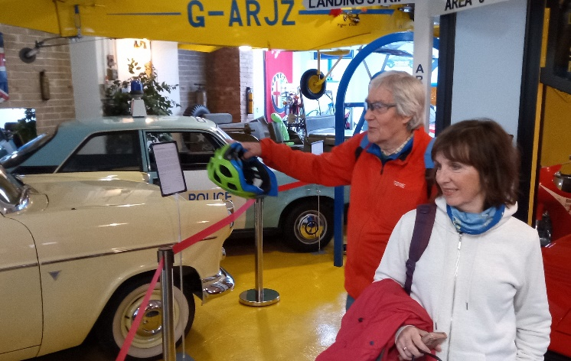
Of interest was the number of similar cars that members had owned at some point in their lifetime and how many were instantly recognisable. A classic treat.
The History of Somerset Levels
Jonathan entertained the club meeting on 7th February by giving a talk on the subject above. He started with the Cider Sea map:
The picture illustrates the extent of flooding possible for a 10 metre sea level rise. This represents a map of the Levels.
The discussion started with evidence of Iron Age sites in the area and the Sweet Track near Shapwick dating from 3800BC.The Romans avoided the Levels by taking the Fosse Way to the east via Ilchester (now the A37). Mention was made of King Alfred hiding out at Athelney and defeating the Danes.
Of particular interest was the diversion of the Tone in 1375 onto its present course towards Burrowbridge.
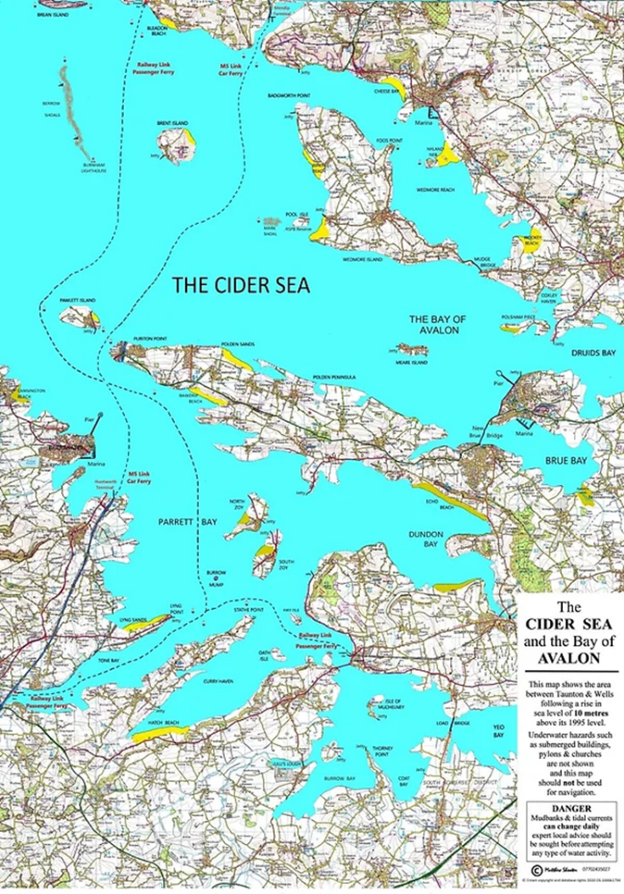
Originally it ran across the moor between East Lyng and Athelney – the barrier is the Balt Moor Wall now with a road running on it.
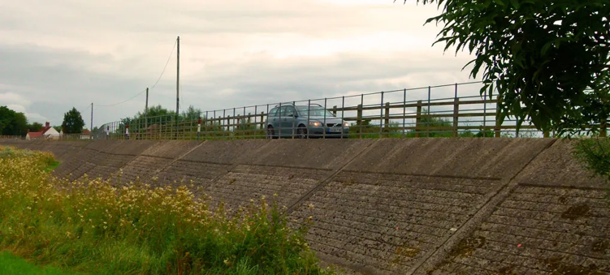
With a mixture of history and present day images where we could view the evidence a lively talk came to an end.

The Strawberry Line
The “Strawberry Line” was the nickname of the Cheddar Valley Line, a Great Western Railway branch line that ran from Witham Junction to Yatton via Shepton Mallet, Wells and Cheddar until the late 1960s.
Since the 1980s, the route has been in the process of being transformed, step by step, into a beautiful greenway through North and Mid-Somerset. The path will be suitable for walkers, cyclists, wheelchair users, mobility scooters, and on some sections, equestrians. Once completed, the Strawberry Line path will run from Shepton Mallet to Clevedon, incorporating the Cheddar Valley Line trackbed wherever possible, as well as much of the disused Clevedon branch line. More than half of the route is already open and yours to explore.
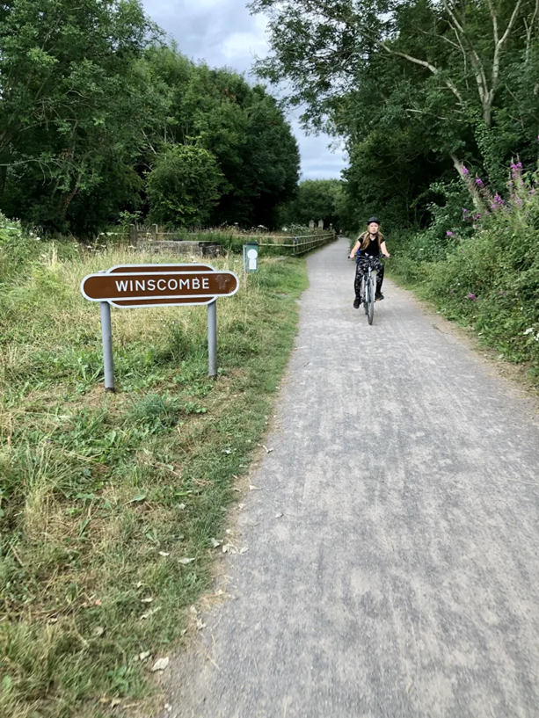
Over two miles of brand-new path have been built in the last two years alone, and there is every chance that most of the route will be finished in the near future. Volunteers of the Strawberry Line Society continue to work in partnership with landowners and local councils to maintain the existing path as well as deliver new sections.
The Cheddar Valley Line became known as the “Strawberry Line” because of the volume of locally grown strawberries that it carried to London and Birmingham markets. Strawberries were collected from a string of Cheddar Valley village settlements sheltered under the southern slopes of the Mendip Hills between Cheddar and Wells for transporting to Yatton Junction. The line was also a vital economic link for passengers, quarrying, agriculture and general goods.
Three railway companies meet in Wells…
Incredibly, Wells once had three railway stations, each serving a different line out of the city and each operated by a separate railway company. Two of these lines would join to become our beloved Strawberry Line… with a little ‘matchmaker’ help from the third line. 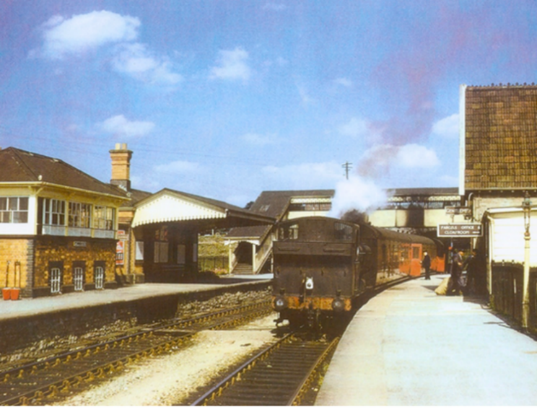
Between 1856 and 1862, the East Somerset Railway built what was in effect a branch line to Shepton Mallet and Wells off the Wiltshire, Somerset and Weymouth Railway at Frome via Witham Junction. In 1859, the Somerset Central Railway constructed a branch line from Glastonbury to Wells off of its main line of Glastonbury to Highbridge (which followed the old Glastonbury canal – you can walk the trackbed at Ham Wall and Shapwick Heath). Three years later, this company merged with the Dorset Central Railway to form the famous Somerset & Dorset Joint Railway. In 1870, the Bristol & Exeter Railway built a branch line, the Cheddar Valley and Yatton Railway, from its mainline station at Yatton to Cheddar and Wells.
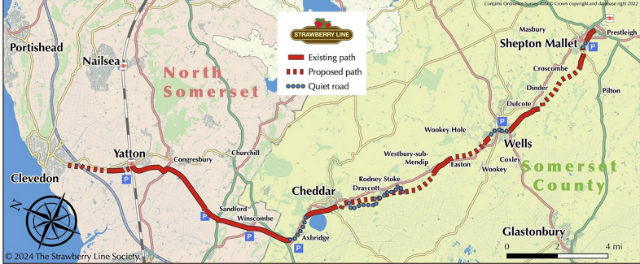

The History of the Bicycle - Part 2
By the 1840s the hobby horse had had its day. Heavy, cumbersome and difficult to steer, it was only propelled by human foot. Macmillan was the first to invent the pedal-driven bicycle. However, he didn't invent the modern bicycle pedals but rather adapted the treadle, Macmillan allegedly completed construction of a pedal driven bicycle of wood in 1839 that included iron-rimmed wooden wheels, a steerable wheel in the front and a larger wheel in the rear which was connected to pedals via connecting rods.
However, the future propulsion would not be with treadles but pedals attached to the front wheel. This was the invention of Pierre Michaux who attached the crank handles from a grindstone to the front wheel. Later, a lever shoe brake was added to operate on the rear wheel by rotating the handlebar and tightening the attached cord.
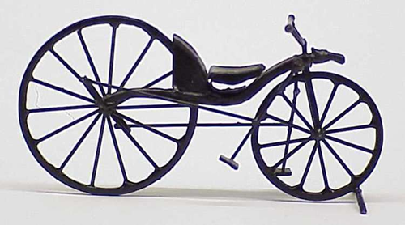
In England this machine became known as the boneshaker – as the name implies due to its jarring effect on roughly surfaced roads. With wooden wheels, metal tyres and bulky frame, it was extremely uncomfortable. It weighed around 27 kg and was capable of 8 mph. The size of the front wheel made the pedal action unpleasantly fast and the rider had to resist the sideways movement of each pedal stroke to keep the bicycle in a straight line. Eventually, in 1869 the first ball bearings had appeared and a ratchet freewheel mechanism on the front wheel. In spite of the drawbacks,
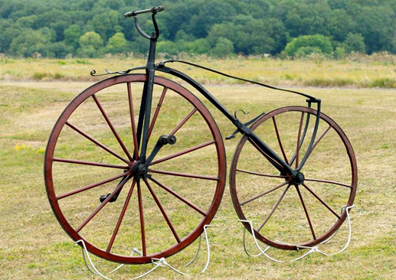
riding a boneshaker gave a sense of adventure and clubs were formed and members rode long distances (e.g. London to John O’Groats.) A pre-cursor to the Tour de France was from Paris to Rouen (123km) race with 100 competitors of which four were women. The winner completed it in 11 hours at an average speed of 7.5 mph. Speed was of the essence and the growing spirit of competition encouraged a need for faster machines.
The front wheel became larger and the seat further forward to give increase pedal power. A step was fitted to the frame to make mounting easier. Thus the Penny Farthing was born. The Ariel weighed in at 23kg costing £8. Instead of the wheels being in compression, the advent of spokes allowed the wheel to be in tension. It relied on wire spokes that pulled the rim towards the hub, making it possible to fit larger and lighter wheels.
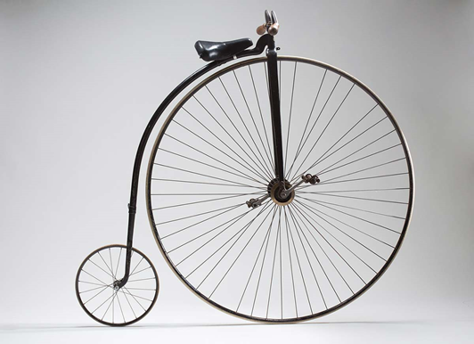
There was a version of the penny farthing that had its rear wheel offset, the handlebars were shortened on one side and lengthened on the other and the pedals were both on the same side it allowed a lady to ride side-saddle. Cycling together became fashionable!
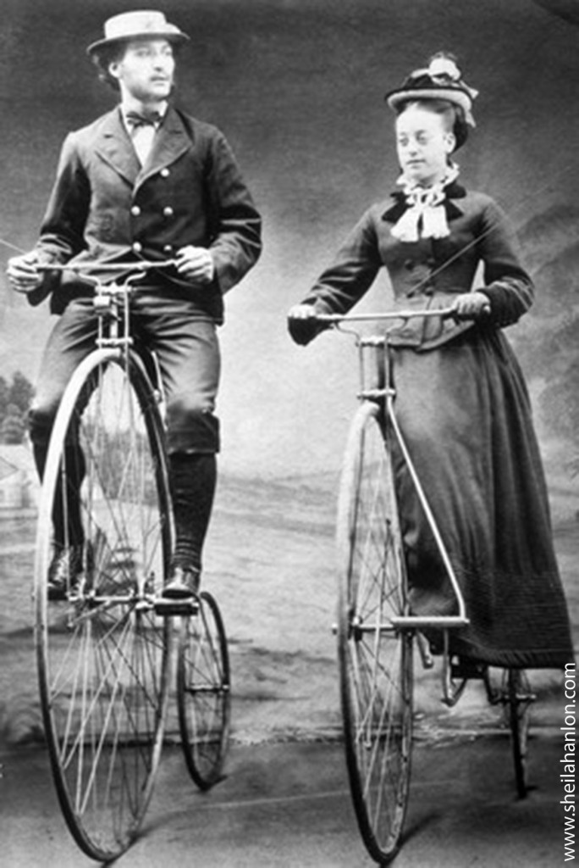
Part 3 – The Safety Bicycle
More than me Jobsworth Guv!
Rarely does one go out on a winter ride around Taunton, without coming to yet another road closed sign! Tree surgeons at work, floods, general road works, Cable laying, trenches and jobs so arcane, it is hard to figure out what is going on. Fortunately 70% of these closures are actually negotiable by a group of cyclists and the majority of workmen, (sorry they always are men), are friendly and accommodating. About 25% of closures, really are closures and no vehicle or cyclist can get through the obstacles. I believe one can give road works a star rating from one star denoting a minor inconvenience, to five stars for a totally impassable road ending up as something of a nightmare for the riders involved.
One such episode occurred last autumn when we came upon a longitudinal trench in the road, about a kilometre long, going down towards Curload. It appeared to be negotiable and we set off along next to the trench until we happened upon a JCB at work, blocking the entire road. Having returned after plodded through several hundred metres of glutinous mud, I realised to my horror that I was unable to actually ride my bike as my SPDs soles were totally plastered with a layer of mud about 10cm thick. However, serendipity was at work here, as just when I was about to face the prospect of walking home, we walked by a stable yard, where a personable young woman was washing the place down with a hose. She kindly lent me this and after several minutes was able to clear the mud from my sandals. Definitely a five star episode.
About 5% pf these closures are clearly passable, but for some reason the workman or official will not allow the group through and reasoning with the individual merely makes them more uncooperative. The A361 was closed near Burrowbridge recently due to flooding and it was here I encountered one of the dreaded “Jobsworth” officials. It was clear that a bicycle could comfortably negotiate the flood by this time and although a barrier was in place at East Lyng I could see the way through. An Environmental employee was manning the barrier and refused to allow me to continue. I realised remonstrating with him was useless, so turned back towards home again. The enormous number of road closures this winter has meant that no ride should be led until the route has been recced first!
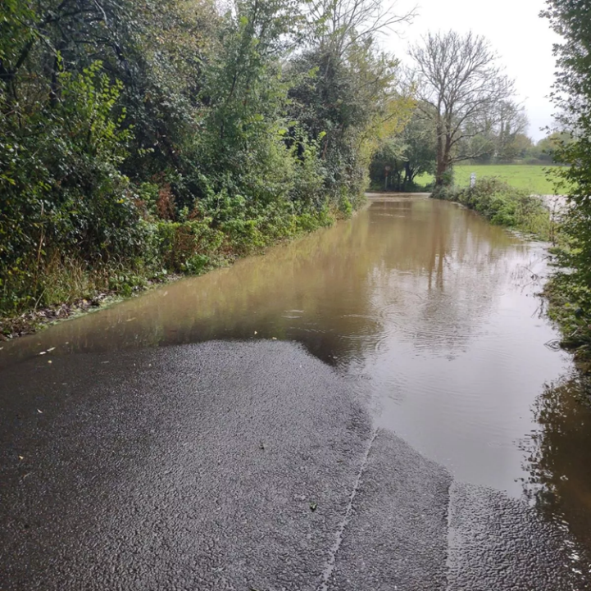
Never mind, we still have hundreds of miles of picturesque Somerset roads to ride along and most the workmen we encounter, are friendly cooperative and helpful.
Happy Cycling!
Submitted by Martin Atton
Go Kids Go!!
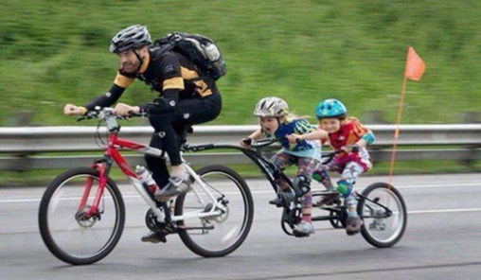

European Transport Study
Physical activity has been widely associated with beneficial health effects. The use of electric-assist bicycles (e-bikes) can lead to increased or decreased physical activity, depending on the transport mode substituted. This study aimed to compare physical activity levels of e-bikers and conventional bicycle users (cyclists) as well as across e-bike user groups based on the transport mode substituted by e-bike. The survey recruited over 10,000 participants in seven European cities. Physical activity levels, measured in Metabolic Equivalent Task minutes per week (MET min/wk), were similar among e-bikers and cyclists (4463 vs. 4085). E-bikers reported significantly longer trip distances for both e-bike (9.4 km) and bicycle trips (8.4 km) compared to cyclists for bicycle trips (4.8 km), as well as longer daily travel distances for e-bike than cyclists for bicycle (8.0 vs. 5.3 km per person, per day, respectively). Travel-related activities of e-bikers who switched from cycling decreased by around 200 MET min/wk., while those switching from private motorized vehicle and public transport gained around 550 and 800 MET min/wk. respectively. Therefore, this data suggests that e-bike use leads to substantial increases in physical activity in e-bikers switching from private motorized vehicle and public transport, while net losses in physical activity in e-bikers switching from cycling were much less due to increases in overall travel distance.
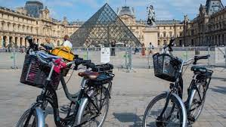
In conclusion, this analysis supports the notion to accept, or even promote, e-bikes as a healthy and sustainable transport option based on e-bikers travel behaviour and self-reported mode substitution. Thus, e-bikes might be used for longer commuting trips than non-electric bicycles. To accommodate (or promote) this new demand and to avoid conflicts with other road users in urban areas, cycling infrastructure should be expanded and may need to be adapted to accommodate higher speeds and address safety needs. The health benefits in terms of physical activity of using e-bikes, particularly when replacing car trips, should be factored in when considering subsidizing e-biking.
Cycling Underwater:
The largest underwater cycle race involved 22 scuba divers competing along the 60-m (196-ft) long, 3-m ( 10-ft) deep 2e2 Underwater Cycling Challenge in Havelet Bay, Guernsey, Channel Islands, UK on 10 September 2006. Three divers competed in the first set of heats, then they had the last eight and the quarters, semis and final were then in twos. The race is held annually. Its original name was: SeaGuernsey Cycle Soumarine.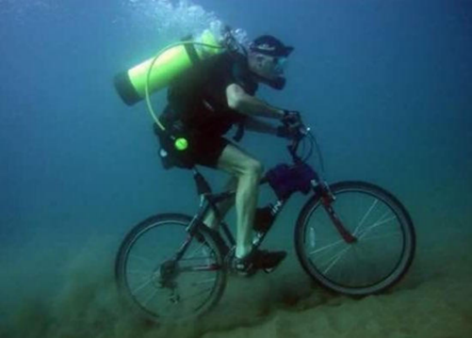
The 2005 winner, Simon Bradbury (UK), remained unbeaten with his time of 1 min 32 sec until the 2007 race, when Philip Eyre (UK) finished in 1 min 20 sec.
From Ian Bright
Dates for your Diary:-
6th March – Committee Meeting (1830) followed by. Brian Martin’s “Garmin/GPS Mapping Workshop” (1930) at The Quaker Meeting House
23rd March – Ride to celebrate the 30th Anniversary of Cycle Somerset
23rd March - Cycle Jumble on sale at West Buckland Village Hall (TA21 9NA) 8am to midday.
3rd April - Committee Meeting (1830) followed by Presentation by Sarah Mitchell, CEO Cycling UK (1930) at The Quaker Meeting House
And a few future dates:
14th July – Summer BBQ event
14th November – A Guided Bird Watching Tour on the River Exe
Suggestions for future editions are always welcome…
Deadline for submission of articles, ideas or photos relating to topical or recent rides:- Wednesday 27th March; anything of personal, local or national cycling interest is always welcome.
Send to Graham Farrington:
graham.farrington@btopenworld.com

