Update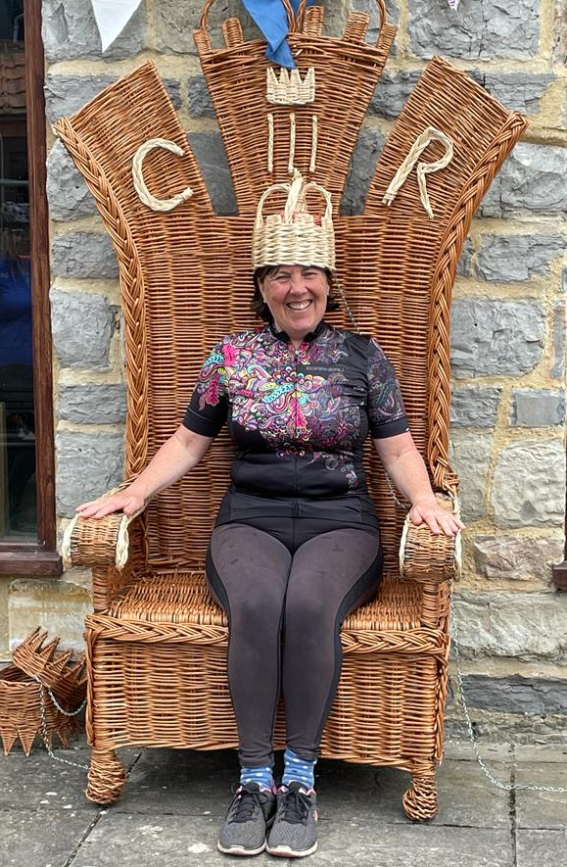The Coronation already seems an age ago but club members were out in numbers at various events and celebrating in their own way. Above is Kate Brown at Willows and Wetlands accepting her crown from fellow riders… if only for a few moments.
What joy, the sun shines and we are all energised and positive. We have four, further, full months of brilliant cycling weather ahead of us and untold adventures to complete... bliss!
We also have four full months of cycling data available on the rides that have been undertaken so far this year, with a total of 80 club rides during January-April, an impressive average of 20 rides per month – great, you hardy lot, considering the weather we’ve had!
Club rides have visited 35 different venues. The most popular venues have been The Kitchen at Langport and Braziers at 7 rides each, with 6 rides each for The New Inn, Halse and The White Post. The 80 rides saw a total of 24 different ride leaders, which is great. Tony Honeybun has maintained his reputation for leading most rides, twice as many as anyone else in fact, 17 in total. Next is Richard on 8 and Arthur with 7.
The number of people on each ride ranged from 2 to 12, with an average of just over 7. The distances covered ranged from 11 to 42 miles, averaging 26.6 miles. Most rides were posted with the “intermediate” pace, but there were also some “slow” and some “brisk”. Our thanks to all the ride leaders for putting on so many rides, with a fantastic variation of venues, distances covered and something for everybody!
Remember the web-site is always a great source of information and don’t forget the club’s Facebook page… so sign up if you haven’t already accessed it.
The Summer BBQ is being planned at Phillipa's house at Oake on Sunday 16th July. It is always a joyous occasion and a great get-together for club members. Save the date in your diary! A charge of £10 per head, payable in advance, is anticipated, details soon.
The next club meeting on 7 June is titled called ‘Come and Have Your Say’ see Richard’s piece in this newsletter.
In the meantime enjoy the improved weather, a heatwave is on the way from Africa for the end of May, sign up and ride!
Ride Well – Ride Visibly - Ride Safely
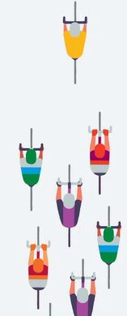
On Your Bike
Thanks to Tracey who came to the recent club meeting from On Your Bike to talk about Bike Fit. After conducting several bike fits with club members she gave a fascinating presentation and nailed a few myths about bike suitability and bike posture. She impressed everyone with her comprehensive mastery of all things bike and the factors that influence ride comfort. She explained that for most people, she could improve ride position and comfort but there were occasions when she had to explain to a cyclist that they were on the wrong bike; disappointing for some but relief for others who could go home and explain that Tracey had said they had to have a new bike.
Thank you Tracey
Helicopter Museum
Graham and Arthur lead a ride to the Helicopter Museum, Locking and a great time was had by all.
Gazette Letter
Two weeks in a row sees a letter published in the Somerset County Gazette suggesting that cyclists are taking over, blamed for the decline of the High Street, ruining the Town Centre and responsible for all the ills and moral decline of modern Britain.
I happen to be a cyclist, I am also a walker… or pedestrian in town centre parlance, I drive a car and if I could afford the fuel I might also fly an aeroplane (or ride a horse as a couple of members already do)! I cannot understand why so many people get angry at the mention or sight of a cyclist. Is it our clothes, the self-satisfied look on our faces or our elegant grace on our chosen mode of travel? Who knows?
The recent letters in the paper made my blood boil… no I mustn’t fall into that trap or I am getting into the same mind-set as the cycling haters? I know, I’ll write the gazette a letter.
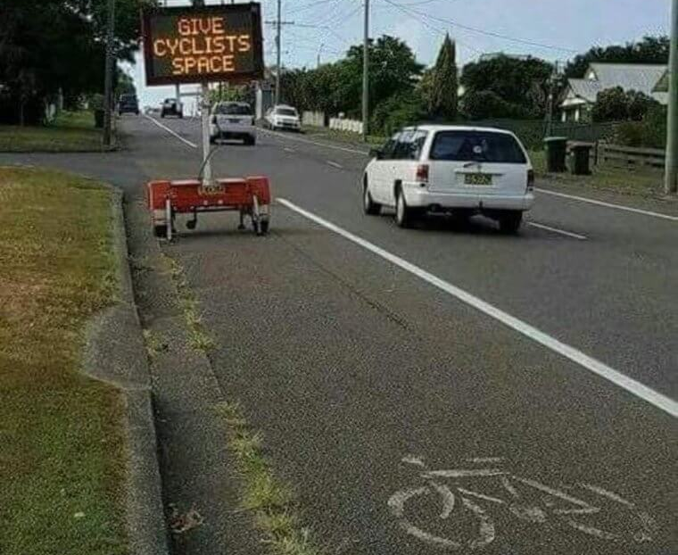
Cycling Quote 1
“It’s a risky business being a cyclist in the UK, there are a lot of people who really dislike us. It’s the Jeremy Clarkson influence — we’re hated on the roads. We just hope people realise we are just flesh and bones on two wheels.”
Victoria Pendleton
The Health Benefits of E-Bikes
In a recent evaluation of the health benefits of riding an e-bike eight general benefits emerged:
i. You will improve your Heart Health. All recent studies have shown that bicycling is associated with better Heart Health;
ii. You will strengthen your Cardiovascular System;
iii. You will boost your Immune System;
iv. You will lower your risk of Type-2 Diabetes;
v. You will lose Weight;
vi. Your general feeling of Well-Being and mood will be lifted;
vii. You will establish a better pattern of Sleep;
viii. You will reduce your overall levels of Stress.
E-bikes are not a trade-off… although cycling, generally, has a positive impact on all of the above there is no falling away if you change to an assisted ride. The one proviso is, of course, you keep cycling… regularly!
Article suggested by Sue Brooks.

Arthur and Gillian A recent trip to London saw Arthur and Gillian enjoying some sight-seeing whilst riding their fold-up bikes. They were impressed by how easily they could get about with great tolerance shown by other road users including Taxi drivers.
1. Which City is the cycling capital of the world?
2. Which City in the UK has the best cycling infrastructure?
3. Which is the world’s most popular bicycle manufacturer by sales?
4. Who owns the largest independent cycle factory in the UK?
5. What % of cyclists own a car?
Answers to Peter and Paul in the usual fashion.
Last month’s winner was Neil Rudrum (again) and, yes there were 42.5 e-bike riders!
Keep Your Bike Moving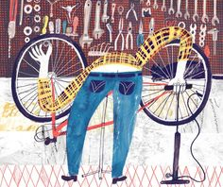1. Keep it clean
To prolong the life of your bike, keep it clean. Tedious, but true. No cleaning kit required – a bucket of soapy water, a sponge and an old toothbrush and a proper degreaser will break down the oil and grit in the chain and gear sprockets.
2. Keep your tyres inflated properly
Poorly inflated tyres are prone to punctures – you need a standing track pump with a pressure gauge to do the job. Look on the side of your tyre for a number followed by the letters PSI. That tells you how much air to put in. Carry a spare tube.
3. Check your brake pads
Worn brake pads equal poor brakes. They are worn if you can hardly see the grooves any more. New brake pads are cheap and easy to fix (any number of websites can show you how). You need a set of Allen keys, some patience… or go to On Your Bike.
4. Silence squeaky brakes
Screeching brakes are often dirty brakes, or at least dirty wheel rims. Clean and dry both properly and 50% of the time, you’ve solved the problem.
5. Tighten saggy brakes
If your brakes have become sluggish and lacklustre – i.e. if you squeeze the brake lever and it moves more than halfway towards the handlebars – you need to tighten them up. If you are confident it’s easy enough, let the internet be your teacher, but if you want certainty get someone who knows how.
6. Get a professional service
Once a year should be fine, ideally at the start of spring if you’ve been brave enough to cycle though winter. There is no shame in getting the pros in. Think of it as your bicycle MOT.
7. Lubrication, lubrication, lubrication
Bike-specific lubricant used sparingly on any parts of your bike where metal touches metal... but there is no point oiling your chain if you haven’t cleaned it properly first – you’ll make matters worse.
8. Check your wheels are “true”
Turn your bike upside down and spin your wheels. If they wobble a little from side to side they need “truing”. It’s a quick fix, but not one for an amateur, as you need special equipment. A bike shop will do this for a small fee.
9. Saddle perfect
As Tracey says , if you are prone to SBS (sore bum syndrome), experiment a little with your saddle, raising or tilting it slightly to suit your riding style. If you get sore knees while cycling, you might have your saddle too low. When you pedal, your legs should be almost straight on the downwards revolution.
10. Buy some latex gloves
Bike oil is a nightmare to get out from under your nails. If it’s too late for that, scrub your hands with washing up liquid and sugar, adding water right at the end. I know Arthur you don’t have an oily chain!
These tips were provided by Helen Pidd, author of Bicycle – ‘The Complete Guide To Everyday Cycling’, published by Penguin.
Welly Wheelers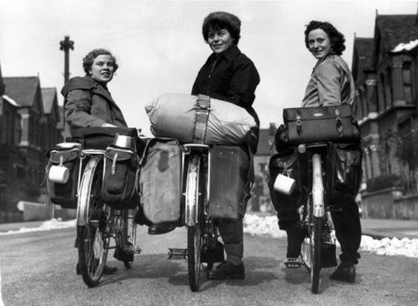Welly Wheelers sent the following out to its members recently: Many of you already know the club has been enthusiastically campaigning for a traffic-free cycle path between Wellington and Taunton. The prospect of a new railway station for Wellington in 2025 has added impetus for an active travel route, and Somerset Council has commissioned consultants to look at all the options. We back a route broadly following the old Grand Western Canal along the river valley ending at Taunton Station. If we succeed, there will be an almost traffic-free route all the way from Bridgwater to Wellington. We have established a separate group in association with the Friends of the Grand Western Canal and the Greenways and Cycle Routes organisation, and have consulted at length with Sustrans. More information about the proposal is available on our website. Over 200 people turned out last year to support such a cycle path, and if you feel able to join them, head over to our website and add your details as a supporter. The more we have, the more convincing our case!
Many Cycle Somerset members are already behind this campaign and some will have received the e-mail from the Wheelers… the more support we generate the greater the likelihood of the scheme being realised... Thanks. Supplied by Arthur Hulls

Cycling Quote 2

Think of bicycles as rideable art that can just about save the world – Grant Peterson
Cycling UK: Cycling helps slow Climate Change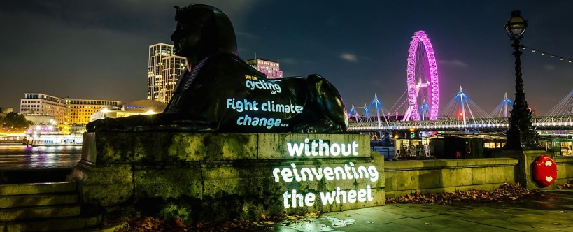How does Cycling help to fight Climate Change?
Human-powered and not reliant on fuel, bicycles don't add pollution to the atmosphere. With a typical passenger vehicle emitting almost five metric tons of carbon dioxide a year from burning fuel, biking cuts back on fuel consumption.

Is cycling completely environmentally friendly?
Bikes don't release harmful emissions that pollute the atmosphere, nor any carbon dioxide that contributes to climate change. Just moderate increases in bicycle use each year could save an estimated 6 to 14 million tons of CO2.
How much CO2 do I save while cycling?
Riding your bike accounts for about 21g of CO2 emissions per kilometre; more than ten times less than a car; with room for improvement as well.
A Lower Carbon footprint - Cycling or Walking?
From most recent calculations, cycling has the lowest carbon footprint of any mode of personal transport, even when compared to walking. From a climate perspective, it makes sense for as many journeys as possible to be made by bike.
So…
Before carbon-intensive travel became widespread, cycling epitomised highly efficient transport, and it still does. Now it’s also part of the solution for a low-carbon future. Cycling is one of the simplest lifestyle choices most individuals can make to reduce their carbon footprint, and it offers huge benefits for health, the economy, air quality and neighbourhoods too. – Various Sources
A Sign of the Times
1. Station Rd – Ride into the path of traffic to stay in the cycle lane, sign aimed at cars not bikes!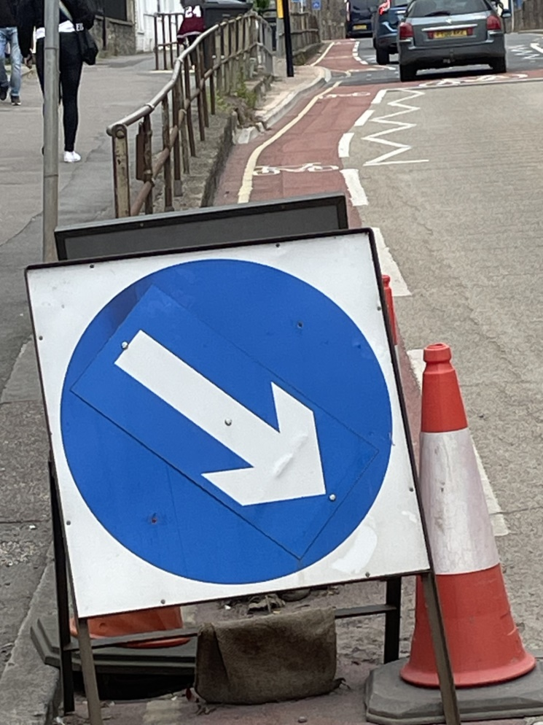
2. Hamilton Rd – Avoid sign to stay in lane.

3. St Andrews – Cycle lane ends, ride when filter lights up, into traffic as vehicles accelerate away!
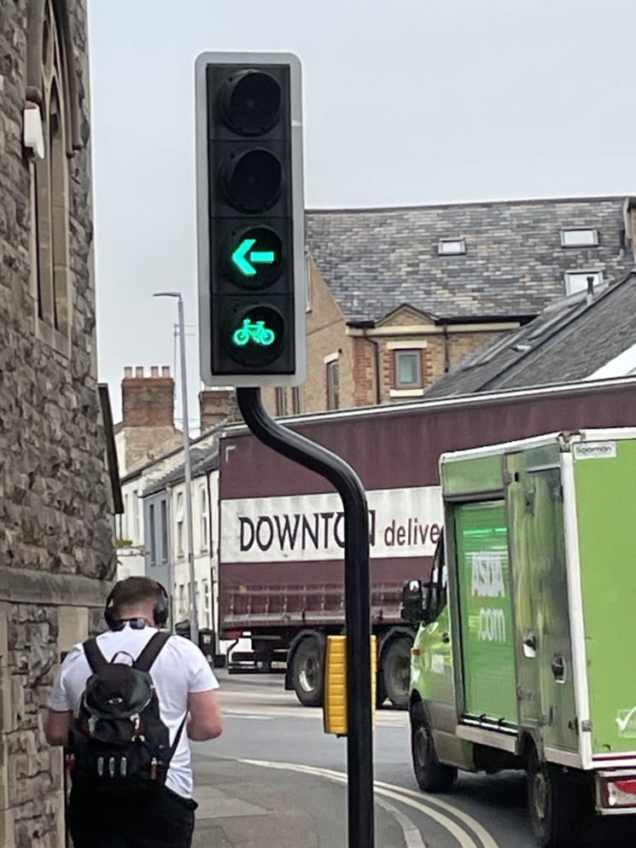
4. No Cycling - Gazette letter writer’s delight!
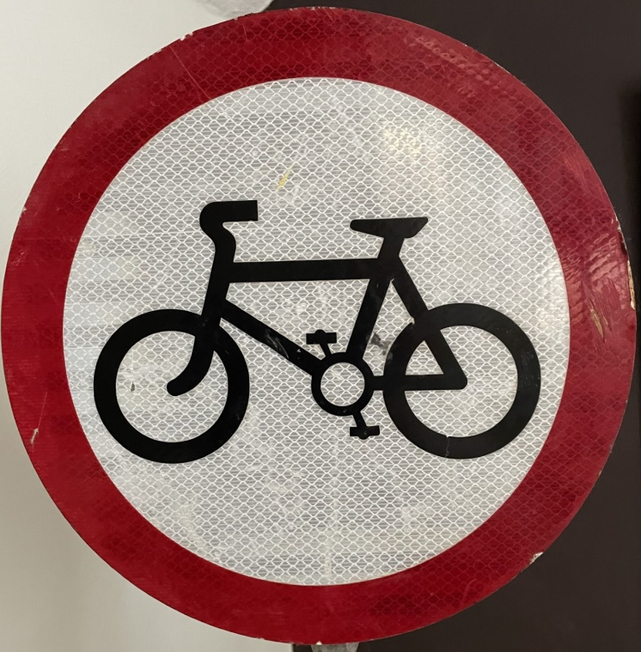
One More Croissant for the Road
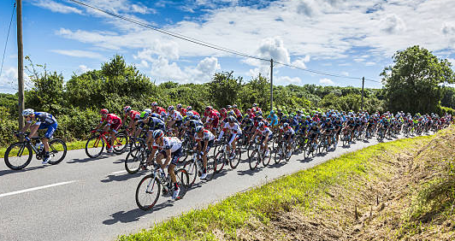
Inspired by Felicity Cloake’s book One More Croissant for the Road, where she undertakes her own 21 stage Tour de France, inserts 21 French recipes and grades the 35 croissants she eats along the way, I am conducting my own poll of club members’ favourite French dishes in time for me to celebrate this year’s Tour which begins on 1st July. I love of Moules Marinieres, although restricted, by Teresa, I eat them in the kitchen with the door closed. What are your culinary French favourites?
Please text, WhatsApp (07962033534) or email me peterhanratty@btinternet.com your favourite French dish adding your name and we can publish the list in next month’s newsletter in plenty of time for the Grand Depart. Similarly, your recommendations for where to buy the best croissants, café, deli or supermarket, would also be appreciated... Merci…Pierre (Peter Hanratty)
Cycling Quote 3
I really don’t like the gym. I like experiences, so I take any chance I can to get on a bicycle or go on a hike! – Blake Lively
The Voice of the Chair 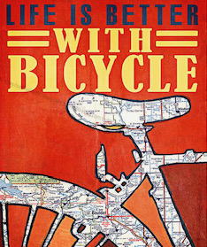At the last Committee meeting (and in this newsletter) Paul Ewings reported that 80 rides had been posted so far this year, slightly up on last year despite sometimes dreary weather that dissuaded some members. Some 35 different venues have been visited with an average of 26 miles cycled.
The average number of riders on each ride was 7 suggesting spaces available for others to join. Thanks to the 3 leaders who have led over half the rides so far this year. It would be good to see others leading a few more? As in previous years, its apparent that many of our members have not joined any or just a few club rides so the benefits of club cycling is being enjoyed by a minority.

The next club meeting on 7 June called ‘Come and Have Your Say’ invites all members to share their views on what works well in the Club and what perhaps we could do differently. Any feedback and new ideas will be welcome. If you have something to say but can't attend the meeting please feel free to email Richard or Sue and we will present them on your behalf.
Richard Sykes - Chair
Reflections on ProvenceWe have recently returned from a visit to Monica’s son and partner in the South of France. I cracked a couple of ribs in a fall from a ladder nine weeks ago (don’t ask), so our cycling around the Luberon National park was even more genteel than usual. Last year, Monica very generously purchased two fine E bikes for us to use during our stay. They live permanently in France, Monica’s son and partner use them while we are back here in Britain.
Below, slightly tongue in cheek I have produced a checklist of plusses and minuses attributable to Provence, compared to a relatively grey and humid Taunton. You may find it useful?
Plusses:
1. The weather is vastly better in Provence with dry air, clear skies and rain that comes as short sharp showers rather than interminable drizzle.
2. Panoramic vistas are the order of the day, the imposing line of the Luberon hills looks down on the vast countryside below, the view uninterrupted, as there are no hedgerows to get in the way.
3. Road surfaces are wonderful, properly maintained, repaired with tarmac and, of course, traffic density is far lower in France.
4. The local Hypermarket offers hundreds of varieties of wine costing a couple of Euros upwards.
Minuses:
1. There are very few birds flying around. The whole area is covered in extensive vineyards, punctuated by the odd field of olive groves and lavender. There are no woods for the birds to hide in, insects to provide the next link in the food chain, or the possibility of any birds seen flying around as they may well get shot!
2. France is eye wateringly expensive. The cost of a small cup of coffee in a café costs about 3 Euros.
3. A much bigger percentage of people smoke in Provence than the UK
4. Sadly the poo fairy has never visited the towns and cities in France, dog owners do not pick it up! 5. The language is French! However, we Brits have no excuses to offer on the language front have we!
Martin Atton
Cycling Quote 4
I go round and round in circles, really, really fast on a big wooden bowl – Victoria Pendleton, when asked about her experiences representing the GB team.Where is Sue’s Bike?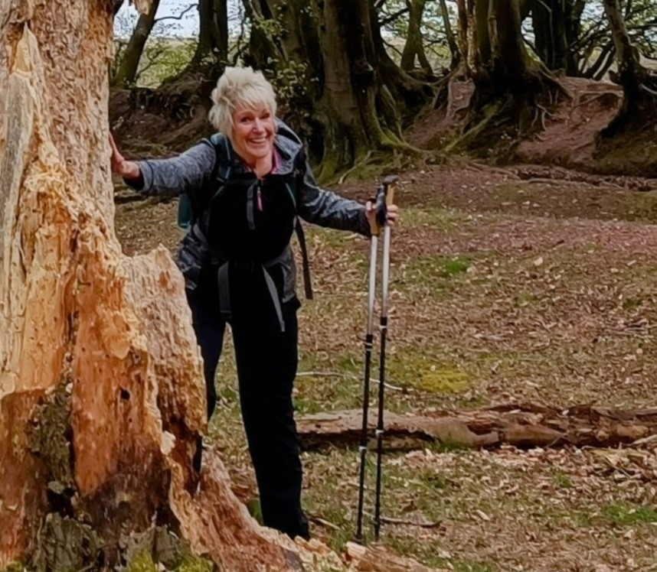This isn’t a photo of Sue Brooks looking for her bicycle, she is on a training walk for her holiday to Northern Spain with Jill Amos, another Cycle Somerset member. They are currently in Spain walking together… we hope they are both having a great time.
Cycling Quote 5
You either love spinning the pedals and watching the scenery whiz by or you don’t. And if you love it, not much can sour you on the idea of riding your bike. – Keith Mills South to Seavington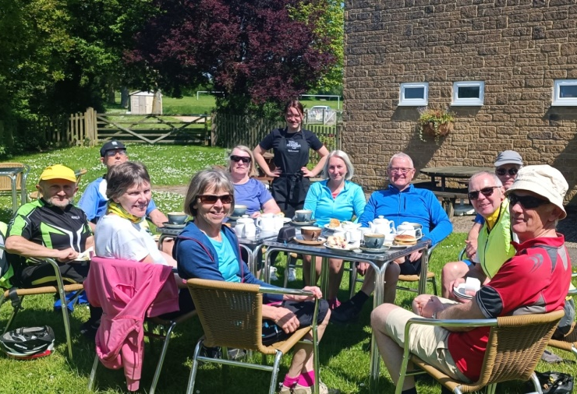On a perfect May Saturday, Richard leads a ride to the Community Café, Seavington St Michael. There is always a warm welcome from the staff and quality refreshments to savour… what a lovely day!Where Am I?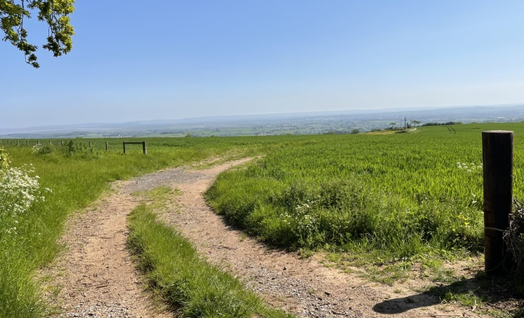The same Saturday but in the opposite direction to the venue above… any ideas where I am?
Finally
It is perfectly possible, on a social cycle, to ride without exertion or breaking a sweat or even raising your pulse significantly. We are not designed for that. Even on a short local ride a sharp hill means the legs will burn a bit, the lungs labour for breath and what feels like every nerve and fibre screaming that this is a ridiculous, unnecessary activity and should stop immediately… until we reach the top, admire the view and give thanks that we are wholly, functionally, truly alive.
The bicycle simply, gloriously magnifies our inbuilt biological capabilities (however modest) and the more we test the theory the more proficient we become. The bike converts our energy into motion with almost 100% efficiency compared to the car at 18%. With a steady input of liquid and sustenance the cyclist could ride forever and even a gentle jaunt sets you apart from those who congratulate themselves on taking the stairs instead of the lift.
Set yourself no targets for speed or distance, to have nothing to do but ride your bike, and all day to do it, is a pleasure to be savoured. 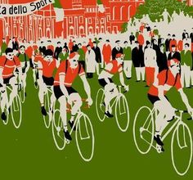 Ideas for future editions are always welcome…
Deadline for submission of articles, ideas or photos relating to topical or recent rides: Thursday 22nd June, anything of personal, local or national cycling interest always welcome.
Send to Peter Hanratty or Paul Harper:
peterhanratty@btinternet.com
paulantharper@live.co.uk

