Update
Another month passes and a move toward normality is realised… at least in terms of cycling. The decision to keep rides to 12 or under at the discretion of ride leaders and size of the coffee stop, is proving popular. The talk has been about the groups being manageable and smaller numbers praised for being more sociable and intimate (I think that is a good summary of messages received).
Membership continues to grow and currently stands at 102. We are aware that some of you rarely ride (a small number never) so if, after joining, there are issues contributing to this reluctance, let us know and we will strive to do something about it.
Last month there were 30 organised rides ranging from just under 20 miles up to just under 50…to venues as widespread as the levels, all the main hills, the boundaries connecting us to Devon and Dorset and all coffee stops in between. Back on Your Bike riders are getting their sea legs and the Ladies continue to meet fortnightly on a Saturday.
Sign up for the BBQ (as posted), graciously hosted by Phillipa, it’s a great social occasion and affords everyone the chance to meet up and see if they recognise members without their cycling clothes on!
Inside is an invitation from TACC inviting us to join them on their Wake Up SCC Highways (details inc).

As mentioned in the last newsletter we intend to acknowledge the coffee stops who kept us functioning throughout the last twelve months.
If you would like to nominate a café send an e-mail to Peter Hanratty or Paul Harper (addresses at the end of the newsletter), naming a café and the reason for nominating them…we’ll do the tallying and feedback. The venues will get a framed certificate.
In the meantime enjoy the remainder of the summer, pedal hard, far and wide but stay safe. The New Inn
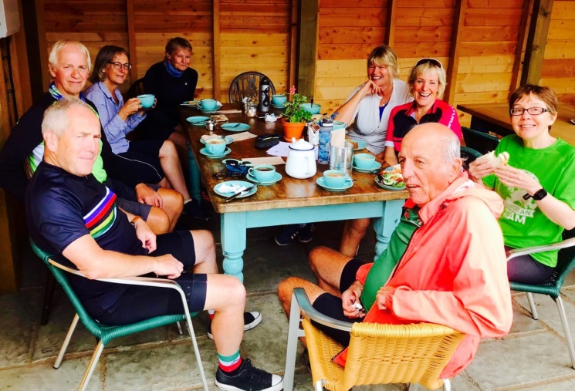
The New Inn has been operating since the lifting of restrictions and is proving very popular with Cycle Somerset riders. It was bought by the community and refurbished to a high standard. It is now a welcoming stop with a wide range of cakes and savouries as these CS people can vouch!
Ivo Johnson
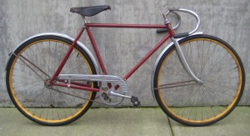
Above: The Ivo Johnson - Junior Racer
Memorial Ride for Karen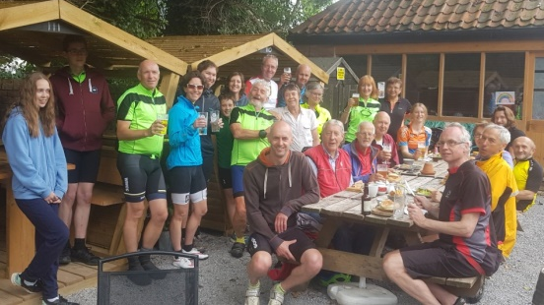On the morning of Karen’s memorial ride I very nearly cancelled/postponed it, initially, due to forecasts for the day of thunderstorms and torrential rain, but in the event the weather was beautiful all day - it just goes to show you should never cancel a ride because of a poor forecast!!
In all 24 of us took part, including a good number from Cycle Somerset. Some had an early start and cycled from Taunton to meet up with others who either rode from the Bridgwater area or drove to Burrowbridge. We then did a lovely 30mile loop of the Polden Hills with Tim Moss leading, joined by 5 of his family who all knew Karen, including Lewis, age 11, what a star! Another group cycled from the Brewhouse a little later and we all met up at the King Alfred for lunch outside in the sunshine, to share our memories of Karen and drink a toast in her memory. The King Alfred was superb, and I think everyone would agree it was a perfect day.
Sue Pawson
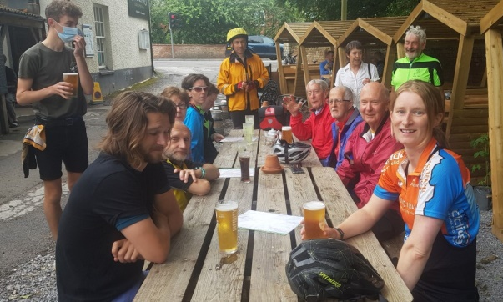
Ray Sharpe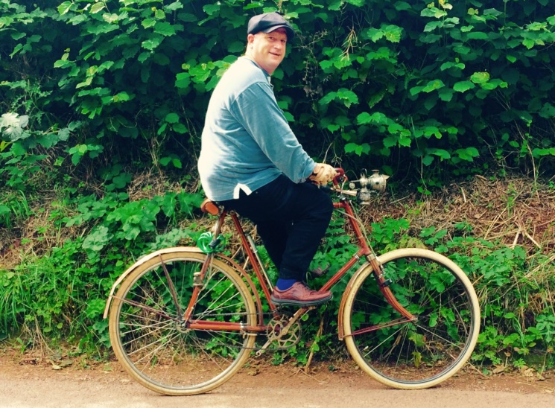Here is the wonderful Ray Sharpe…we met Ray on a recent ride, at the top of the Quantocks. Ray rides a 1903 Hercules cycle, with an early 3 speed, which he has restored. He cycles from North Petherton twice a week, up one route to the top of the hills and returns by another. For those darker evenings, he has a gas carbide lamp to light his way. Pleased to have his picture taken he would have chatted to the group all morning if I hadn’t insisted on reaching Fyne Court to meet our exacting schedule!
Back On Your Bike
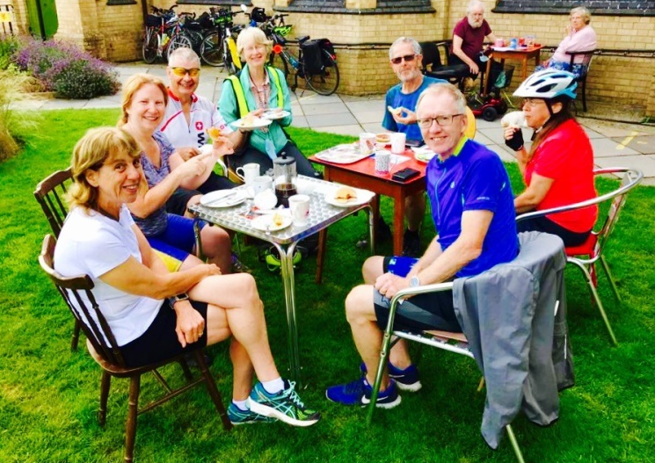
Here is the Back on Your Bike group enjoying a well-earned coffee at Skittles, Norton Fitzwarren, another one of the fine community run cafes we come across on our travels
An Interview with the Chair
Why do you cycle? I feel better when I do it than when I don’t – a sense of freedom, exercise and well-being.
How often do you go out cycling each week? I go out 4 or 5 times a week.
Which of your bikes is your favourite? My Roberts (pictured) is favourite having been custom built as a retirement present to myself but sadly of late my electric bike has become the most used with the feature of providing assistance going uphill (to enable me to continue cycling as I used to given my current arrhythmia problem)
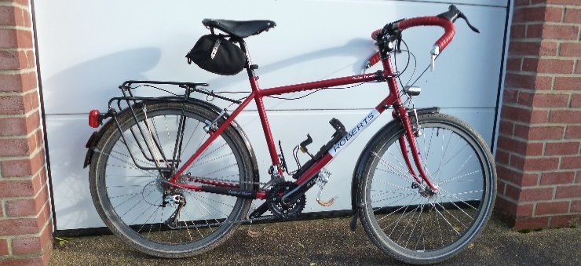
What do you always take with you when cycling? I take a drink, first aid kit, waterproof, pump, tubes, tyre levers and multi tool. Often spare gloves, warmer top, rain legs.
Do you mend punctures or buy a new inner tube? I normally use a new replacement tube occasionally I may use a patch. (Punctures are relatively rare!!)
What is your favourite cycling gadget? Topeak has a small bent wire to hold the chain together (pictured) while you insert a magic link or when reconnecting the chain.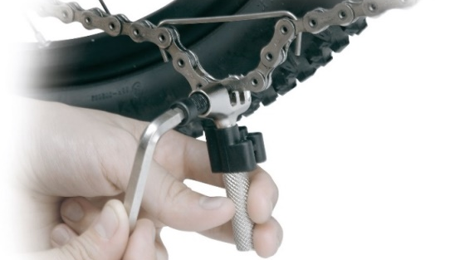
What top cycling tip would you pass on to others? Looking and positioning is the key to cycling safely.
With £100 to spend on cycling, what would you buy? A genuinely waterproof, waterproof jacket (or probably towards the cost of one!).
What is your favourite local ride? Over the Polden Hills to Westhay/Shapwick with good views across the levels towards Glastonbury Tor and a bacon sandwich to die for!
What single thing would most improve matters for Cycle Somerset cyclists? Greater driver education and tolerance would help.
Potholes
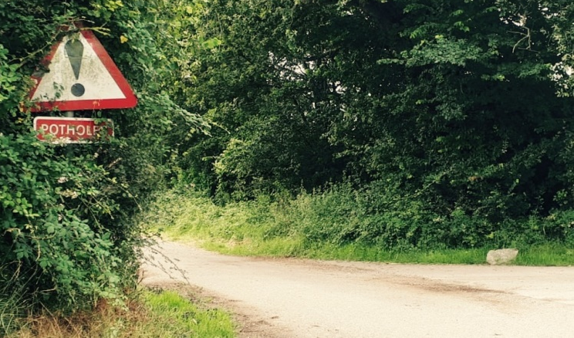 We are not sure what you think but, although helpful, erecting a permanent sign warning cyclists about the imminent potholes ahead seems a bit extravagant (and worryingly long term)! Wouldn’t it be a cheaper option to have filled them all in once they were discovered or reported? Thanks to Richard Sykes for sending in the photo.
Have You Seen the Cruffin Man?
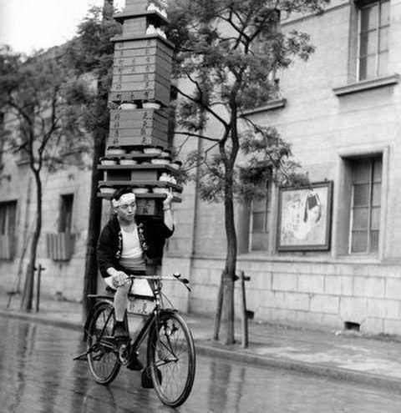A Tuesday ride to Braziers with a view to enjoying a rare delicacy (raising the hopes of the rest of the group too) proved an anti-climax, on arrival, when we found there were no Cruffin. In these times of shortages and non-deliveries, it seems the Cruffin man has had a better offer. Here he is delivering his precious cargo to a rival coffee stop! If you haven’t tried a Cruffin, you are in for a treat! It’s a cross between a Muffin and a Croissant…one taste leads to future gluttony! They always have them on Saturdays (but are a gamble during the week!).Back on Your Bike 2
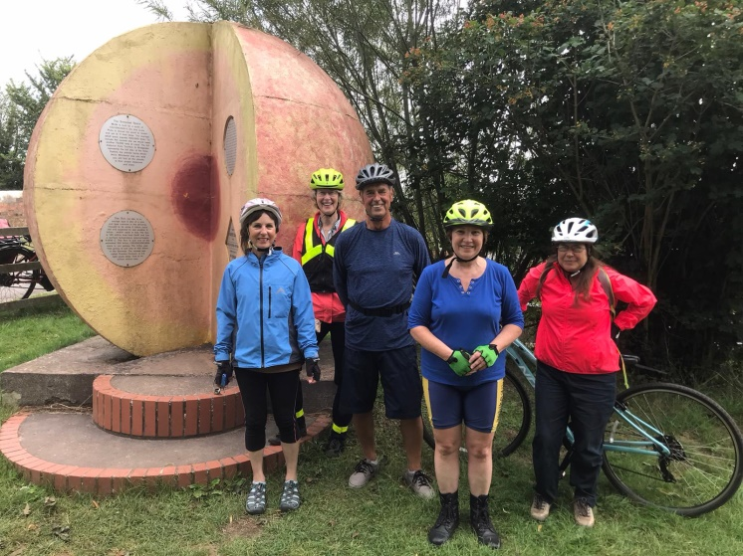The Back on Your Bike group enjoy a bit of sun.
Cycling Safety
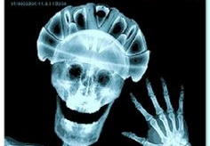Nobody needs reminding that a good helmet is a sound investment. Don’t go cheap, do your research and buy a recommended model… it could be the difference should the worst happen. Nobody needs to be reminded, but we have anyway!The Duck Lady
Those of you who have ever been on an early ride, setting off down the canal to the swing bridge at the start of the day, will no doubt remember Sandra who was always on her bike roving up and down feeding the ducks. Sadly departed, there is now a memorial bench at her favourite spot, celebrating her life…very fitting!
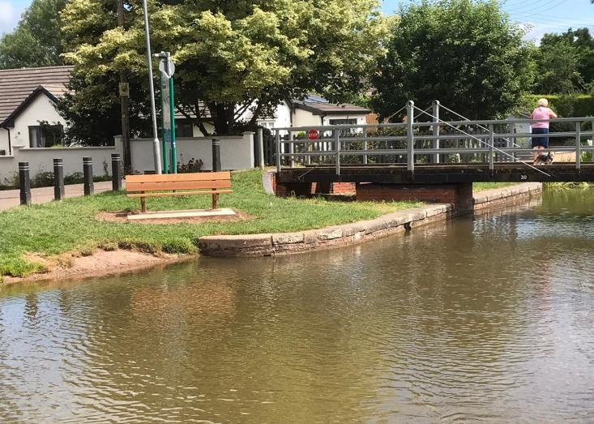
Arthur Recommends the Bamboo Bicycle Club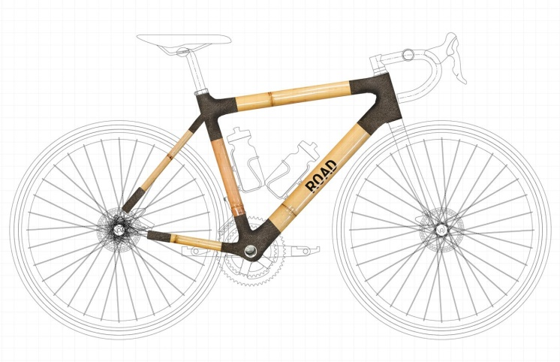Founded in 2012 by two engineers, James Marr and Ian McMillan, the BBC team has helped members build over 500 bespoke frames in their workshop in Hackney Wick, making everything from tandems to BMXs and even children’s bikes. You name it and they’ll help you make it (as long as it’s out of bamboo), with the dynamic duo recently creating a 3D bamboo bike in just eight hours for the London Design Museum If you want to make your own, the Bamboo Bicycle Club in East London is a great place to start, offering both weekend workshops or bespoke build-your-own kits that they’ll send to your home. (Various models start at £330 a kit).Artistic Cycling
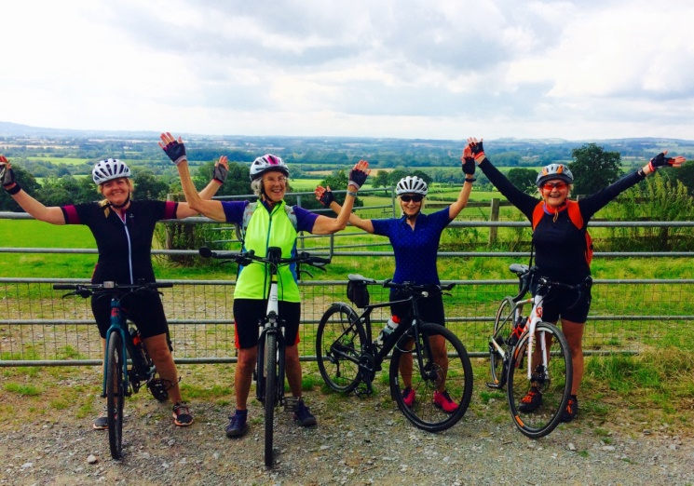
The grace, charm and originality are there but the synchronisation needs a little work. As an Olympic sport it might qualify… the four of them recently performing in a gateway at Cushuish (near you)!
Solar Cycling Path
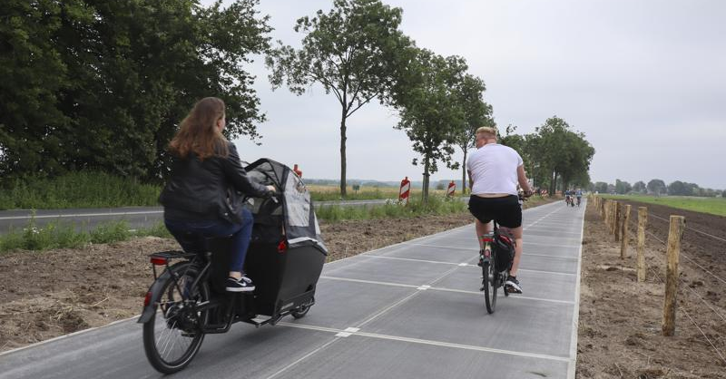
A Dutch province opened what they believe to be the world's longest solar bicycle path recently, a mix of sustainable energy and emission-free travel. Pupils at a local school were the first to ride the 330-metre-long path in the village of Maartensdijk, near Utrecht. Prefabricated blocks of concrete top a transparent layer allowing sunlight to hit solar cells encased in the blocks. The project aims to establish if roads can be used to create solar energy, serve cyclists and slash emissions.

"It's very important if we want to be climate-neutral by 2040, you have to dare to use innovation, and this is very innovative,” an official, said. The path is the longest yet developed. The first cyclist to put it to the test, 11-year-old Machiel, said, “It's better for the environment, and I prefer to have solar panels in the bike path than in fields.”
See You Later Alligator
In recent weeks an American cyclist was attacked by an alligator and seriously injured after falling down an embankment. He was able to break free and crawled to a spot where a bystander helped him and he was given first aid by emergency services. A member of the Airborne Mountain Bike Club said he was an accomplished rider and it was just “bad luck” that the alligator was there when he slipped into the water…I think I’ll give The Levels a miss for a while and, since you ask, he was wearing a helmet!

Characters of the Cycling World.
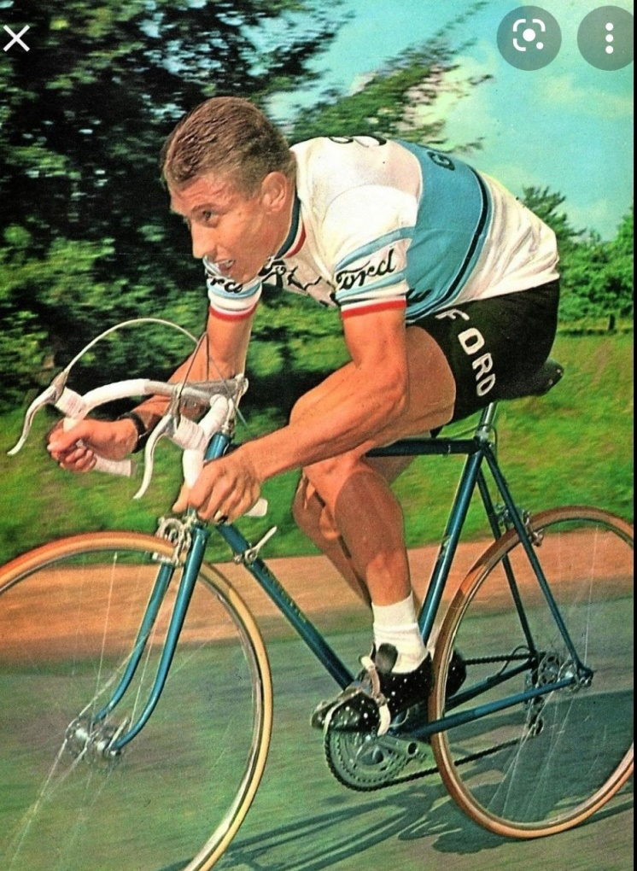
Competitive cycling is an arduous sport, hundreds of miles a week training, extreme physical effort every day and pay a tiny fraction of the ridiculous sums given to modern footballers. Having been a regular cyclist for over half a century, I have enjoyed watching and reading about road cycling characters livening up the world of cycling. Eddy Merckx and Mark Cavendish are household names, one, for being the greatest all round cyclist ever the other, the greatest road sprinter of modern times with 34 Tour de France stage wins.

I first encountered an extrovert character called Brian Tadman in 1974, when I spectated at a road race in Essex. As Brian drew up to the start, a member of the crowd stepped out to hand him a pint of beer which he downed in one!! This was more impressive than his riding, as he finished well down the field. An early time trialling hero of mine; Alf, “The King”, Engers was a London baker and always dressed flamboyantly in colourful outfits, accompanied by a signature neckerchief and an earring. On one occasion he was pulled over by the police and searched for recreational drugs. As you can imagine, his outrage knew no bounds, because at the time he was a National Time Trial champion! In 1978, Alf was the first man to get under 50 minutes in a 25 mile time trial. No aerodynamic aids in those days, just every cycle component drilled with hundreds of holes for lightness. What a total waste of time and effort that was!

Mario Cipollini, otherwise known as the Lion King, was the greatest road sprinter in the 1990’s at 6’ 3” and heavily muscled, it is no wonder he never finished a mountain stage in the tour. He was often seen in a state of collapse by the side of the road on the first mountain stage he encountered. He has the distinction of winning the fastest ever stage of the tour, with an average of 50kmph on a 194 kilometre stage. Often in trouble with authority for wearing outrageous cycling outfits he regularly paused to comb his luxuriant locks before burning the rest of the field off. He was very well known in Italy, appearing on Italian TV wearing a suit from his collection of several hundred.

Jacques Anquetil was the winner of five tours between 1957 and 1964. Jacques was a brilliant rider against the clock, winning all the time trials up for grabs. He was lightly built and had a strange “toe pointing downwards” pedalling style and was a household name in his native France. His training regime included a diet of foie gras, champagne, red wine and Gauloise cigarettes. This probably led to his early death, at only fifty three?

Finally there has to be a mention of the “Tashkent Terror”, Djamolidine Abdoujaparov. With a name like that how can you keep a low profile? Another road sprinter, with a stocky build, he was famous for his crazed riding at the end of every sprint stage. In 1991 he caused a massive crash in the TDF on the Champs Elysees 100 yards before the finish, by striking a barrier and bringing down dozens of riders behind him; despite being badly injured Djamolidine managed to limp over the line unaided to claim his green jersey.
Martin “Allez” Atton
MAD ON A BIKE
Recently
I’ve taken to cycling
Today
I wore my specialist shorts
Madonna style
For the very first time
Lycra virgin.
Poem by Paul Cookson
James May II
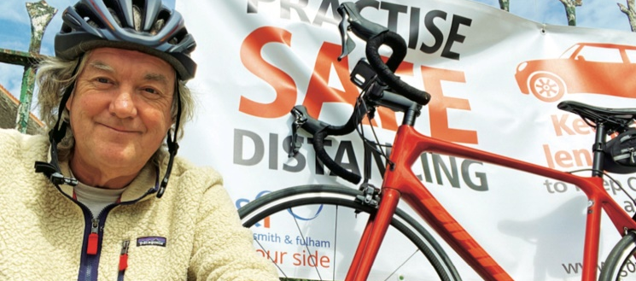
Top Tips for Bike Building: James suggests: 1. Befriend a proper bike shop – for parts, advice, things you forgot; 2. Choose your frame wisely - no dents, twists, repairs spoilt threads; 3. Sticker Up – most bike makes logos are available on eBay; 4. Do a dry run – do a loose assembly, to see if it all joins up before you strip and paint; 5. Buy proper cable cutters – snip without fraying; 6. Tune to Radio 3 (or 4) as suggested last month, get restoring!
Remember to Sign Up for the BBQ
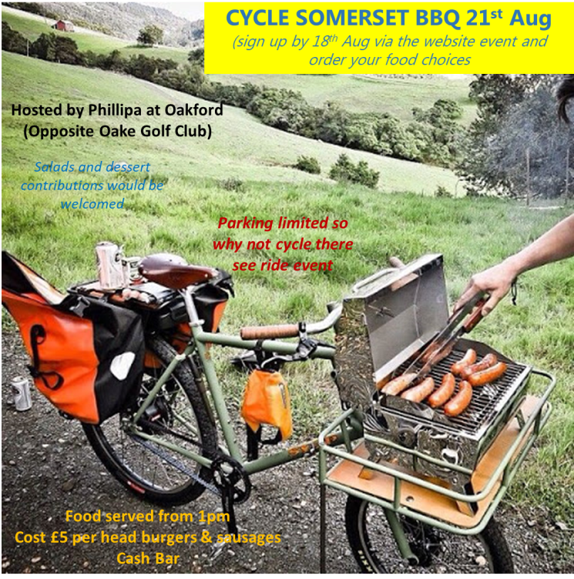
TACC-Wake-Up Rally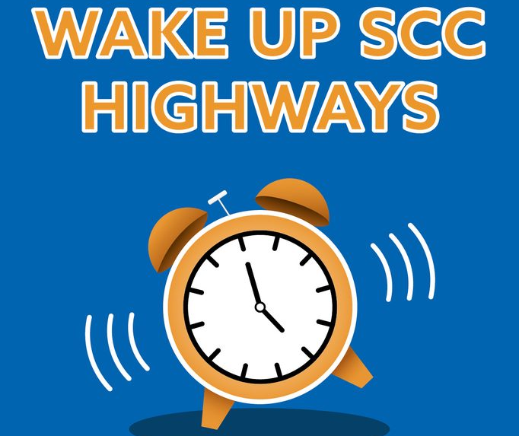
Join the TACC ‘Wake up’ Rally for better cycling in Somerset, Weds 1st Sept, Taunton.
Action to improve cycling needs to start now. Somerset CC has to stop dragging its feet with warm words but little tangible progress. Design and maintenance of cycling infrastructure needs to improve. TACC has tried to support the County Council in a variety of ways, putting our own time into this. The Government is calling on Highway Authorities to enable active travel. Numerous polls show strong public support for better cycling provision. The pandemic showed the appetite for walking and cycling more, when the threat from car traffic is reduced. There is a climate emergency.
The County has funded four major road schemes in as many years in Taunton. We are struggling to think of any new free standing cycling routes in the same period (other than add-ons to road schemes).
Somerset County Council-please do some meaningful implementation! Rally details are:
There will be a marshalled ride from Victoria Park leaving 11.30am through town to County Hall. We are asking people to register by emailing thetacc@contact.org.uk Then on to County Hall 12 noon for presentation of an alarm clock at 12.15pm. Can you come-please reply to let us know. Bring bicycle bells to ride on Weds 1st Sept.
We would love to see families on the ride and at County Hall. We will join up with groups from across Somerset who will also be taking part.
Taunton – Welly Cycle Path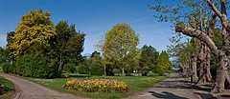The dream of a cycle path between Taunton and Wellington is closer to reality thanks to two key groups combining their efforts. Taunton Area Cycling Campaign and Citizens UK Somerset are working together to plan the route. The route is likely to follow the A38, on the south side, but be separated from the traffic.
“We feel the time has come for the implementation of the first substantial piece of cycling in the area at a time when there should be a real drive to enable people to use alternatives to their cars – this project will make a major difference,” said Mike Ginger of TACC.
A team consisting of officers from SCC and Somerset West and Taunton Council, Sustrans, Welly Wheelers, Business Members and Wellington Town Council are working on mapping the design. Jonathan and Karin on LE TOUR DE CYMRU
Day 1: The Tour started in Newport station car park where we could not get a 7-day parking ticket despite help from a parking warden who suggested going to the station ticket office. Now legally parked, bikes laden, we set off on our trek. We learnt to steer smoothly with heavy panniers as we went under and over busy flyovers to join the Monmouth canal. A flight of 14 canal locks near Newport rises 50 metres over 1km and is being restored with heritage grants. From Cwmbran the canal winds around the hills and there is a café at Goytre wharf, next to some old lime kilns, popular with locals. Parts of the canal path were overgrown only just navigable with panniers. At Abergavenny route 56 goes though the Castle meadows alongside the River Usk. The cafes in the town have outdoor seating, making for a European feel in the centre.
Day 2: Woke up to beautiful sunshine at the farmhouse B and B where we had been made so welcome. Route 42 tracks the river Honddu valley to its source passing the famous Llanthony Priory. Up the valley the road was closed due to a landslide but was passable by bike. After a lunch stop at a canoe centre in Glasbury we continued along country lanes to the town of Builth Wells.
Day 3: Route 8 took us along the Wye valley. On the map there was a 4km section of track which was part of the old coach route – it was steep, stony and mostly un-rideable. As a walk it might have been classified ‘moderate’ but on cycles it was more like ‘technical MTB,’ yet Sustrans gave it their OK!
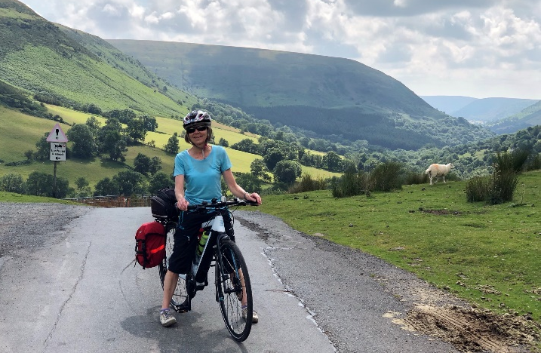
Lunch was in the square in Rhayader, we marvelled at the HGV drivers negotiating a narrow junction with holiday traffic unfamiliar with Welsh towns. Tea was at Llangurig post office, the owner watering hanging baskets and a flower display in the community centre gardens. An ascent out of the village meant a good downhill section to the attractive town of Llanidloes; famous for the Chartist revolt in 1839, a campaign for democratic rights prompted by the collapse of the local textile industry. During the unrest, three local people were arrested and held in a hotel until the protesters forced their release, only then to be re-arrested and ‘transported’ (presumably to Australia). The Unicorn Hotel was the best stay of the trip, and the evening meal was a mid-point treat.
Day 4: A 50-mile marathon with over 1000m of climbing, a fine morning but then the heavens opened. We arrived at the posh Lake Vrynwy Hotel dripping wet. We thought that pre-booking (essential) would enable us to get to get lunch without too much grief but had to stand the trial of the temperature probe – “Stand 1-2 inches away,” said the stern receptionist, “you need to wipe your forehead as it is reading Lo, wipe it again- still Lo, try the back of your hand.” It was 3rd time lucky for Karin (temp reached 36) Ditto for Jonathan but still Lo before the forearm came up trumps with a temp of 35.6. Making it to the panoramic dining room, we felt a bit incongruous amongst the hunting shooting Porsche driving clientele!
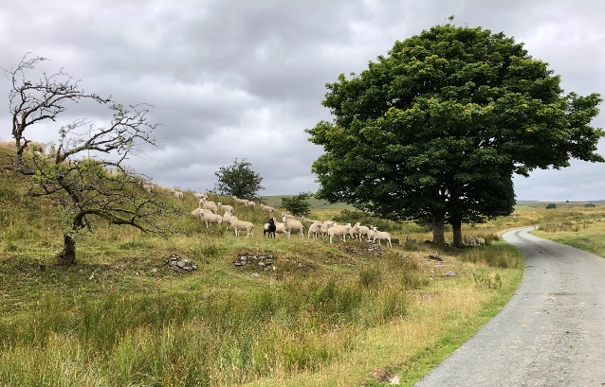
Having survived this ordeal, we climbed through a valley with ancient woodlands (temperate rain forest) followed by a fantastic descent into Bala. The owner of the B and B ran a water sports centre so was not perturbed when 2 wet cyclists arrived.
Day 5: Wet and windy with a forecast of lightning in early afternoon, we braved the hills and weather up to Pentrefoelas on the A5 where there is a chocolatier who sells delicious hot chocolate and cakes. We decided to avoid the high ground at mid-day and continued on the busy A5 to Betws y Coed. Bright flashing lights and Hi Vis were essential for this section. After lunch in a café in Llanwrst we re-joined our intended route along the Conwy valley staying the night in a luxuriously converted chapel. Our return to Newport was by train. Thanks to Jonathan and Karin Sladden for sharing their trip!
It’s Tuesday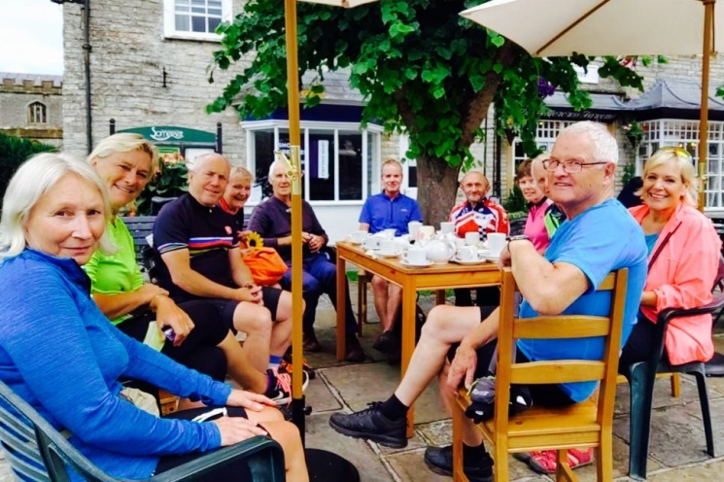…so Sue leads a ride to Somerton!
Ideas for future editions are always welcome…
Deadline for submission of articles, ideas or photos relating to topical or recent rides: Thursday 9th September, anything of personal, local or national cycling interest always welcome. Send to Peter Hanratty or Paul Harper:
peterhanratty@btinternet.com
paulantharper@live.co.uk
Finally 1: New changes to the Highway Code will give pedestrians greater priority over cars at junctions and crossings (Details next month)!
Finally 2: Remember the more closely cycling is studied the greater the agreement about its positive impact on health, well-being and…the environment. It’s a universal panacea; scientists even agree that regular cycling makes you look younger. As Plato said, “Whoever is of a calm and happy nature (and rides a bike) will hardly feel the pressure of age.”
So when you are out on a club ride next week you are helping to save the planet, you are getting fitter, you are lifting your mood…and you are looking younger with every turn of the pedal!
What’s not to love? Take Care.

